1. **PotatoesFarmerFeb.c**

cbmc PotatoesFarmerFeb.c --unwind 1 --trace

* 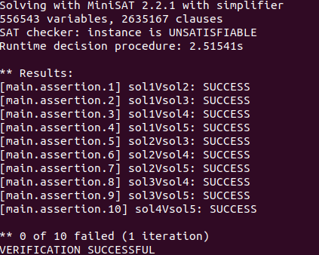

cbmc PotatoesFarmerFeb.c --unwind 2 --trace

* 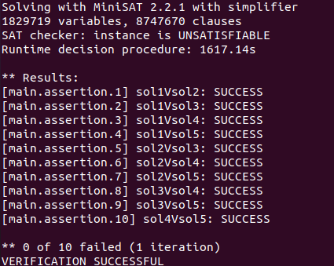

cbmc PotatoesFarmerFeb.c --unwind 5 --trace

* Brute Force Checker Faired better in this case and the cbmc was running for more than 6 hours before we used Ctrl+C to end the process.
  + Why did the Brute Force Checker fair better?
    - Here 1<=x<=1000 and 1<=y<=1000 and there are only 1 million possible inputs. In such cases, it is much faster to brute force check as shown below.
    - 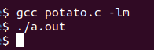
    - There is nothing printed out as the functions give the same result at all the points.
    - This process took less than 30 seconds as compared to more than 6 hours with no results in case of CBMC checking with --unwind 5 option.

1. **ToyStory.c**

cbmc ToyStory.c --unwind 1 --trace

* 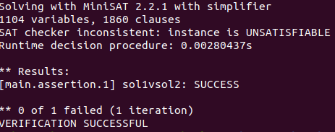

cbmc ToyStory.c --unwind 2 --trace

* 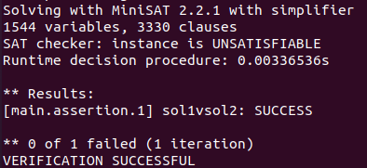

cbmc ToyStory.c --unwind 3 --trace

* 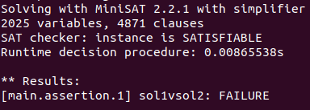
* Trace:

Off by 1 error observed

Violated property:

file ToyStory.c line 55 function main

sol1vsol2

return_value_sol1 == return_value_sol2

1. **EncryptMessage.c**

cbmc EncryptMessage.c --unwind 1 --trace

* 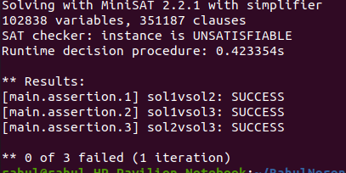

cbmc EncryptMessage.c --unwind 2 --trace

* 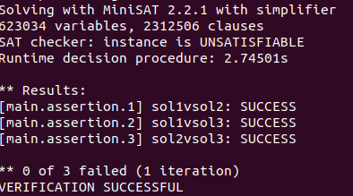

cbmc EncryptMessage.c --unwind 5 --trace

* 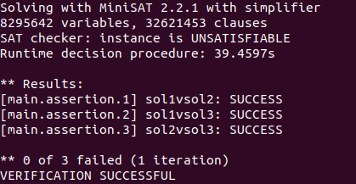

cbmc EncryptMessage.c --unwind 5 --trace

cbmc EncryptMessage.c --unwind 10 --trace

* Cbmc was running for more than 6 hours before we used Ctrl+C to end the process.

1. **EasyAbc.c**

cbmc EasyAbc.c --unwind 1 --trace

* 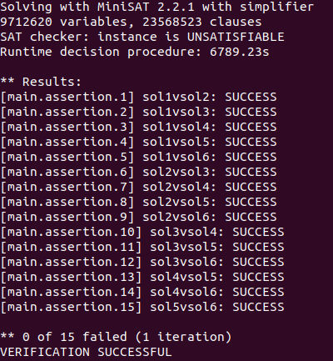

1. **Problem1.c**

cbmc Problem1.c --unwind 1 --trace

* 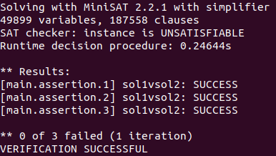

cbmc Problem1.c --unwind 2 --trace

* 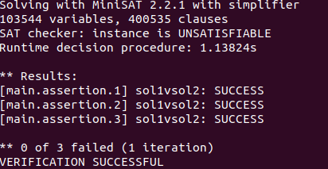

cbmc Problem1.c --unwind 3 --trace

* 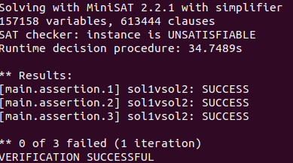

1. **SumOfPalandromicNumbers.c**

cbmc SumOfPalandromicNumbers.c --unwind 1 --trace

* 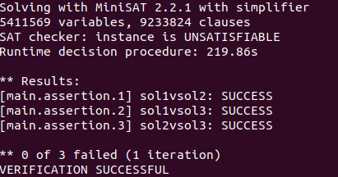

1. **ArrangingTheNumbers.c**

cbmc ArrangingTheNumbers.c --unwind 1 --trace

* 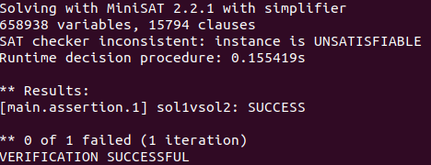

cbmc ArrangingTheNumbers.c --unwind 2 --trace

* 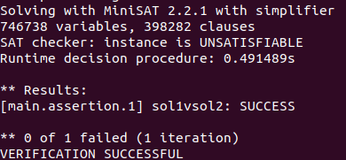

cbmc ArrangingTheNumbers.c --unwind 3 --trace

* 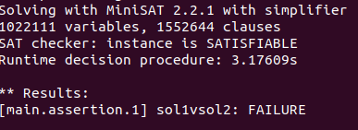

Violated property:

file ArrangingTheNumbers.c line 57 function main

sol1vsol2

return_value_sol1 == return_value_sol2

1. **ChefAndSpecialNumber.c**

cbmc ChefAndSpecialNumber.c --unwind 1 --trace

Running for more than an hour suggests there are no errors detected and that it could be Unsatisfiable.

cbmc ChefAndSpecialNumber.c --unwind 1 --trace

* Running for more than an hour suggests there are no errors detected and that it could be Unsatisfiable.

1. **But1Get1.c**

cbmc But1Get1.c --unwind 1 --trace

* 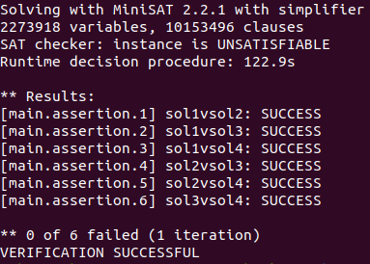

1. **ArrangingCupCakes.c**

cbmc ArrangingCupCakes.c --unwind 1 --trace

* Running for more than an hour suggests there are no errors detected and that it could be Unsatisfiable.

1. **DistributeApples.c**

cbmc DistributeApples.c --unwind 1 --trace

* 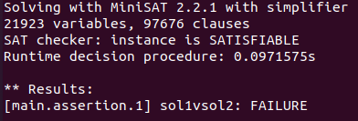
* Violated property:

file DistributeApples.c line 66 function main

sol1vsol2

return_value_sol1 == return_value_sol2

** 1 of 1 failed (1 iteration)

VERIFICATION FAILED

1. **WituaAndMath.c**

cbmc WituaAndMath.c --unwind 1 --trace

* 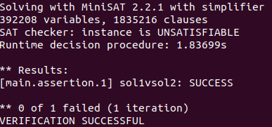

cbmc WituaAndMath.c --unwind 2 --trace

* Takes a long time to run, which suggests it is unsatisfiable.

1. **CharlieAndPrimeNumbers.c**

cbmc CharlieAndPrimeNumbers.c --unwind 1 --trace

* Takes a long time to run, which suggests it is unsatisfiable.

1. **TomAndJerryGame.c**

cbmc TomAndJerryGame.c --unwind 1 --trace

* 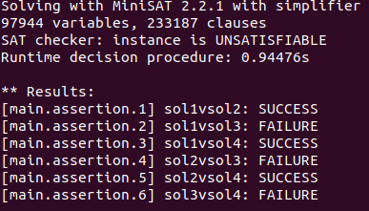

Violated property:

file TomAndJerryGame.c line 107 function main

sol1vsol3

return_value_sol1$0 == return_value_sol3

Violated property:

file TomAndJerryGame.c line 109 function main

sol2vsol3

return_value_sol2$0 == return_value_sol3$0

Violated property:

file TomAndJerryGame.c line 111 function main

sol3vsol4

return_value_sol3$1 == return_value_sol4$1

** 3 of 6 failed (3 iterations)

VERIFICATION FAILED

cbmc TomAndJerryGame.c --unwind 2 --trace

* 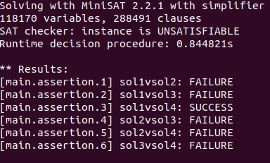

Violated property:

file TomAndJerryGame.c line 106 function main

sol1vsol2

return_value_sol1 == return_value_sol2

Violated property:

file TomAndJerryGame.c line 106 function main

sol1vsol2

return_value_sol1 == return_value_sol2

Violated property:

file TomAndJerryGame.c line 107 function main

sol1vsol3

return_value_sol1$0 == return_value_sol3

Violated property:

file TomAndJerryGame.c line 106 function main

sol1vsol2

return_value_sol1 == return_value_sol2

Violated property:

file TomAndJerryGame.c line 107 function main

sol1vsol3

return_value_sol1$0 == return_value_sol3

Violated property:

file TomAndJerryGame.c line 109 function main

sol2vsol3

return_value_sol2$0 == return_value_sol3$0

Violated property:

file TomAndJerryGame.c line 110 function main

sol2vsol4

return_value_sol2$1 == return_value_sol4$0

Violated property:

file TomAndJerryGame.c line 106 function main

sol1vsol2

return_value_sol1 == return_value_sol2

Violated property:

file TomAndJerryGame.c line 107 function main

sol1vsol3

return_value_sol1$0 == return_value_sol3

Violated property:

file TomAndJerryGame.c line 109 function main

sol2vsol3

return_value_sol2$0 == return_value_sol3$0

Violated property:

file TomAndJerryGame.c line 106 function main

sol1vsol2

return_value_sol1 == return_value_sol2

Violated property:

file TomAndJerryGame.c line 107 function main

sol1vsol3

return_value_sol1$0 == return_value_sol3

Violated property:

file TomAndJerryGame.c line 110 function main

sol2vsol4

return_value_sol2$1 == return_value_sol4$0

Violated property:

file TomAndJerryGame.c line 111 function main

sol3vsol4

return_value_sol3$1 == return_value_sol4$1

1. **CAndK.c**

cbmc CAndK.c --unwind 1 --trace

* 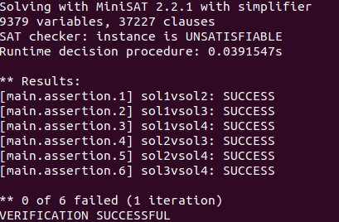

cbmc CAndK.c --unwind 2 --trace

* 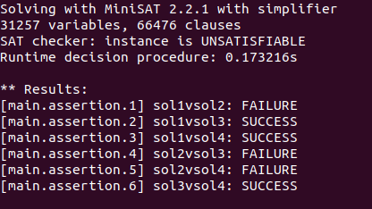

Violated property:

file CAndK.c line 71 function main

sol1vsol2

return_value_sol1 == return_value_sol2

Violated property:

file CAndK.c line 74 function main

sol2vsol3

return_value_sol2$0 == return_value_sol3$0

Violated property:

file CAndK.c line 75 function main

sol2vsol4

return_value_sol2$1 == return_value_sol4$0

cbmc CAndK.c --unwind 3 --trace

* 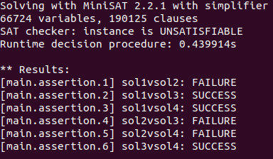

Violated property:

file CAndK.c line 71 function main

sol1vsol2

return_value_sol1 == return_value_sol2

Violated property:

file CAndK.c line 71 function main

sol1vsol2

return_value_sol1 == return_value_sol2

Violated property:

file CAndK.c line 74 function main

sol2vsol3

return_value_sol2$0 == return_value_sol3$0

Violated property:

file CAndK.c line 71 function main

sol1vsol2

return_value_sol1 == return_value_sol2

Violated property:

file CAndK.c line 75 function main

sol2vsol4

return_value_sol2$1 == return_value_sol4$0

Here sol 1!=sol2, sol2!=sol3, sol2!=sol4

1. **CountingSubS.c**

cbmc CountingSubS.c --unwind 1 --trace

* 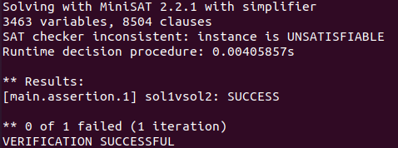

cbmc CountingSubS.c --unwind 2 --trace

* 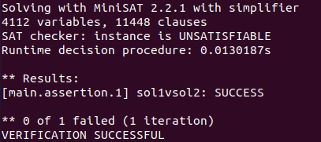

cbmc CountingSubS.c --unwind 3 --trace

* 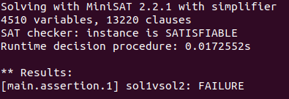

Violated property:

file CountingSubS.c line 50 function main

sol1vsol2

return_value_sol1 == return_value_sol2

** 1 of 1 failed (1 iteration)

VERIFICATION FAILED

1. **FriendOrGf.c**

cbmc FriendOrGf.c --unwind 1 --trace

* 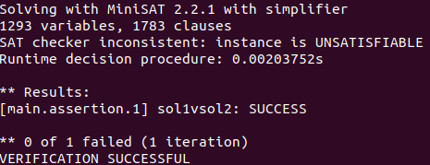

cbmc FriendOrGf.c --unwind 2 --trace

* 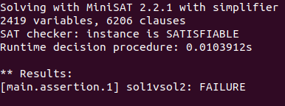

Violated property:

file FriendOrGf.c line 66 function main

sol1vsol2

return_value_sol1 == return_value_sol2

** 1 of 1 failed (1 iteration)

VERIFICATION FAILED

sol1!=sol2

1. **MaxDiff.c**

cbmc MaxDiff.c --unwind 1 --trace

* 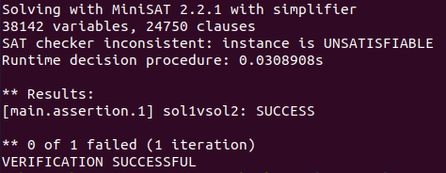

cbmc MaxDiff.c --unwind 2 --trace

* 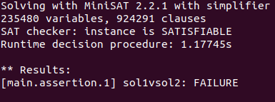

Violated property:

file MaxDiff.c line 72 function main

sol1vsol2

return_value_sol1 == return_value_sol2

** 1 of 1 failed (1 iteration)

VERIFICATION FAILED

**sol1!=sol2**

1. **DilemmaCards.c**

cbmc DilemmaCards.c --unwind 1 --trace 1

* 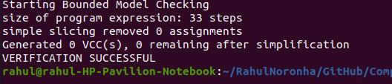

cbmc DilemmaCard.c --uniwind 4000 --trace

* 

1. **SelfDestructingStrings.c**

cbmc SelfDestructingStrings.c --unwind 1 --trace

* 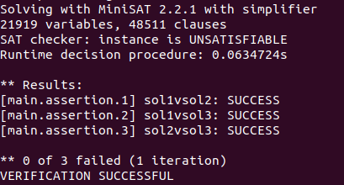

cbmc SelfDestructingStrings.c --unwind 2 --trace

* 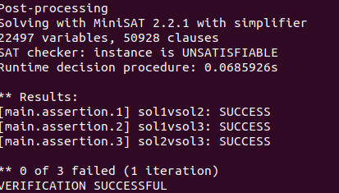

cbmc SelfDestructingStrings.c --unwind 3 --trace

* 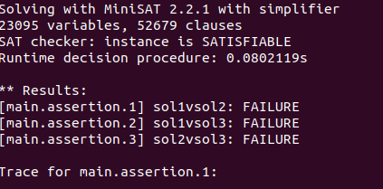

Violated property:

file SelfDestructingStrings.c line 111 function main

sol1vsol2

return_value_sol1 == return_value_sol2

Violated property:

file SelfDestructingStrings.c line 111 function main

sol1vsol2

return_value_sol1 == return_value_sol2

Violated property:

file SelfDestructingStrings.c line 112 function main

sol1vsol3

return_value_sol1$0 == return_value_sol2$0

Violated property:

file SelfDestructingStrings.c line 111 function main

sol1vsol2

return_value_sol1 == return_value_sol2

Violated property:

file SelfDestructingStrings.c line 112 function main

sol1vsol3

return_value_sol1$0 == return_value_sol2$0

Violated property:

file SelfDestructingStrings.c line 112 function main

sol1vsol3

return_value_sol1$0 == return_value_sol2$0

Violated property:

file SelfDestructingStrings.c line 113 function main

sol2vsol3

return_value_sol1$1 == return_value_sol2$1

** 3 of 3 failed (1 iteration)

VERIFICATION FAILED

1. **StrangeFunction.c**

cbmc --unwind 1 --trace

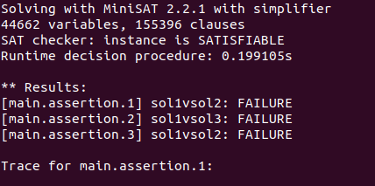

sol1!-sol2 sol1!=sol3 sol1!=sol2

Violated property:

file StrangeFunction.c line 145 function main

sol1vsol2

return_value_sol1 == return_value_sol2

Violated property:

file StrangeFunction.c line 145 function main

sol1vsol2

return_value_sol1 == return_value_sol2

Violated property:

file StrangeFunction.c line 146 function main

sol1vsol3

return_value_so**l1$0 == return_value_sol3**

Violated property:

file StrangeFunction.c line 145 function main

sol1vsol2

return_value_sol1 == return_value_sol2

Violated property:

file StrangeFunction.c line 146 function main

sol1vsol3

return_value_sol1$0 == return_value_sol3

Violated property:

file StrangeFunction.c line 147 function main

sol1vsol2

return_value_sol2$0 == return_value_sol3$0

1. **PenaltyShootOut.c**

cbmc PenaltyShootOut.c --unwind 1 --trace

* 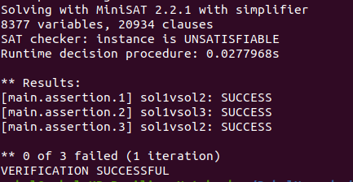

cbmc PenaltyShootOut.c --unwind 2 --trace

* 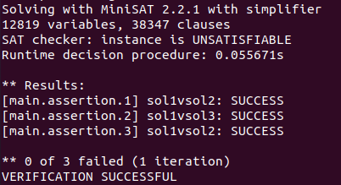

cbmc PenaltyShootOut.c --unwind 3 --trace

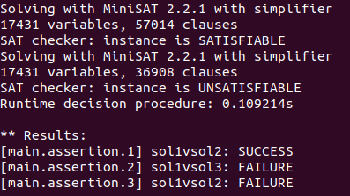

Violated property:

file PenaltyShootOut.c line 111 function main

sol1vsol3

return_value_sol1$0 == return_value_sol3

Violated property:

file PenaltyShootOut.c line 112 function main

sol1vsol2

return_value_sol2$0 == return_value_sol3$0

** 2 of 3 failed (2 iterations)

VERIFICATION FAILED

1. **BeautifulGarland.c**

cbmc BeautifulGarland.c --unwind 1 --trace

* 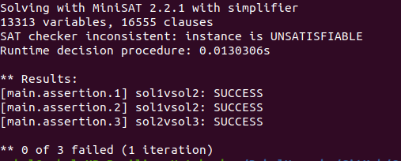

cbmc BeautifulGarland.c --unwind 2 --trace

* 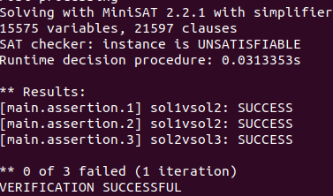

cbmc BeautifulGarland.c --unwind 3 --trace

* 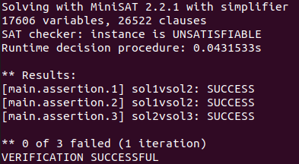

cbmc BeautifulGarland.c --unwind 4 --trace

* 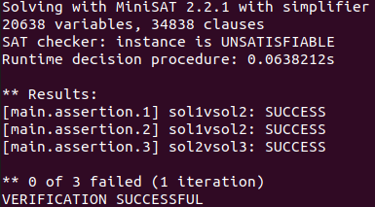

cbmc BeautifulGarland.c --unwind 5 --trace

* 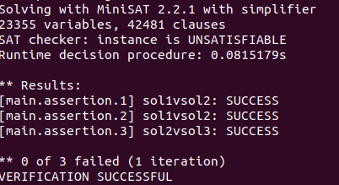

cbmc BeautifulGarland.c --unwind 10 --trace

* 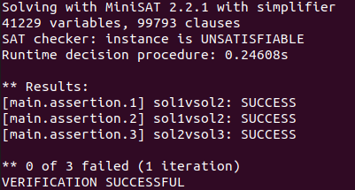

1. **Anagram.c**

cbmc Anagram.c --unwind 1 --trace

* 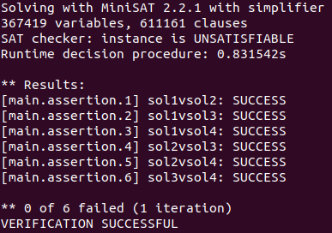

cbmc Anagram.c --unwind 2 --trace

* 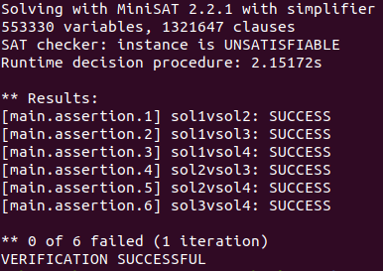

cbmc Anagram.c --unwind 3 --trace

* 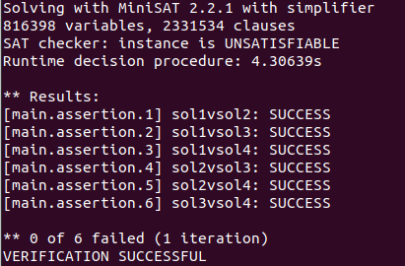

cbmc Anagram.c --unwind 4 --trace

* 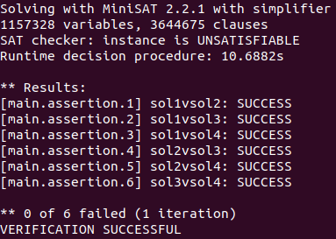

cbmc Anagram.c --unwind 5 --trace

* 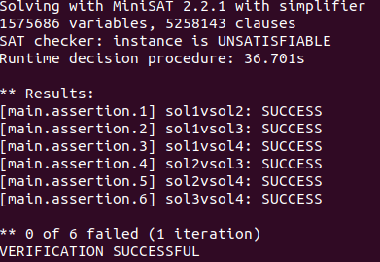
* It is unsatisfiable and it proves sol1==sol2==sol3==sol4==sol5==sol6

1. **CookingMachine.c**

cbmc CookingMachine.c --unwind 1 --trace

* 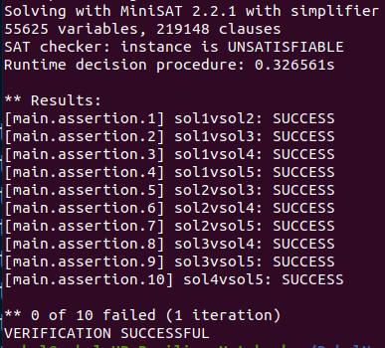

cbmc CookingMachine.c --unwind 1 --trace

* 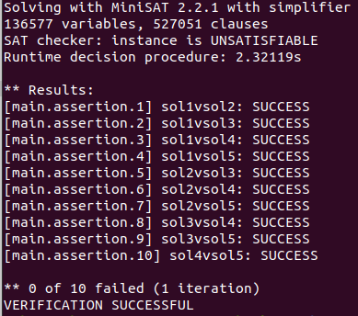

cbmc CookingMachine.c --unwind 3 --trace

* 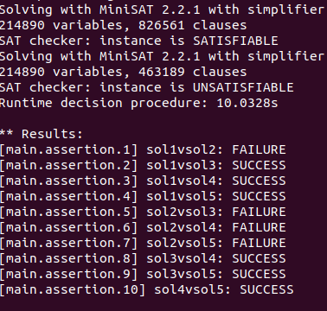

Violated property:

file CookingMachine.c line 159 function main

sol1vsol2

return_value_sol1 == return_value_sol2

Violated property:

file CookingMachine.c line 159 function main

sol1vsol2

return_value_sol1 == return_value_sol2

Violated property:

file CookingMachine.c line 163 function main

sol2vsol3

return_value_sol2$0 == return_value_sol3$0

Violated property:

file CookingMachine.c line 159 function main

sol1vsol2

return_value_sol1 == return_value_sol2

Violated property:

file CookingMachine.c line 164 function main

sol2vsol4

return_value_sol2$1 == return_value_sol4$0

Violated property:

file CookingMachine.c line 159 function main

sol1vsol2

return_value_sol1 == return_value_sol2

Violated property:

file CookingMachine.c line 163 function main

sol2vsol3

return_value_sol2$0 == return_value_sol3$0

Violated property:

file CookingMachine.c line 164 function main

sol2vsol4

return_value_sol2$1 == return_value_sol4$0

Violated property:

file CookingMachine.c line 165 function main

sol2vsol5

return_value_sol2$2 == return_value_sol5$0

This means sol1!=sol2 sol2!=sol3 sol2!=sol4 sol2!=sol5 which clearly means sol2 is different from the rest.

1. **CoinsAndTriangle.c**

cbmc CoinsAndTriangle.c --unwind 1 --trace

* 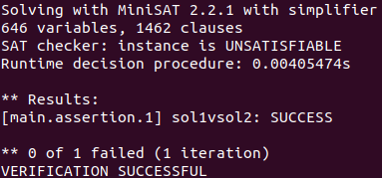

cbmc CoinsAndTriangle.c --unwind 2 --trace

* 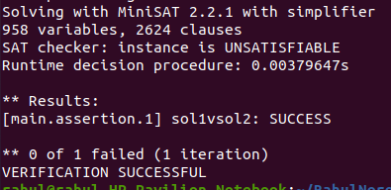

cbmc CoinsAndTriangle.c --unwind 3 --trace

* 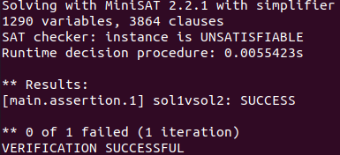

cbmc CoinsAndTriangle.c --unwind 4 --trace

* 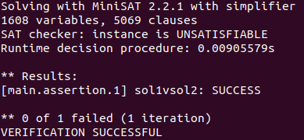

cbmc CoinsAndTriangle.c --unwind 5 --trace

* 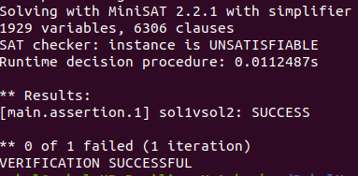

cbmc CoinsAndTriangle.c --unwind 10 --trace

* 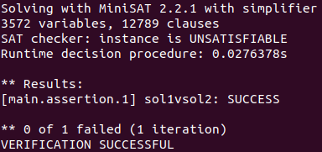

cbmc CoinsAndTriangle.c --unwind 100 --trace

* 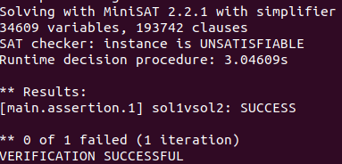

1. **ChefAndKeyboard2.c**

cbmc ChefAndKeyboard2.c --unwind 1 --trace

* 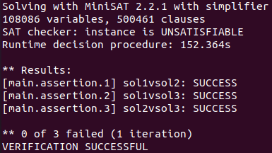

cbmc ChefAndKeyboard2.c --unwind 2 --trace

* 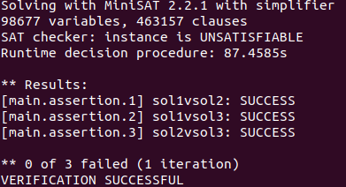

cbmc ChefAndKeyboard2.c --unwind 3 --trace

* 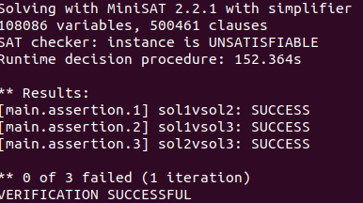

cbmc ChefAndKeyboard2.c --unwind 4 --trace

* 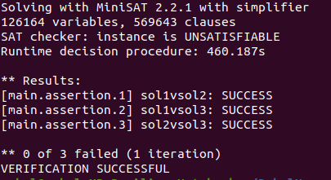

1. **FlatLand.c**

cbmc FlatLand.c --unwind 1 --trace

* 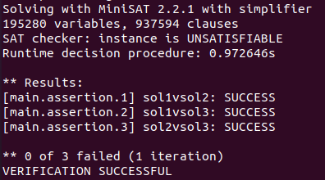

cbmc FlatLand.c --unwind 2 --trace

* The running takes a very long time which suggests it is Unsatisfiable.

1. **Problem2.c**

cbmc Problem2.c --unwind 1 --trace

* 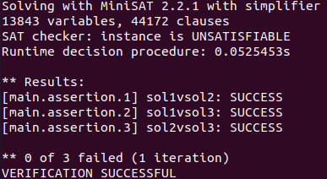

cbmc Problem2.c --unwind 2 --trace

* 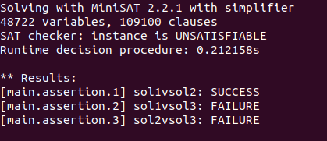
* This suggests that sol3 is different from sol1 and sol2 and has a high probability of being incorrect.

Violated property:

file Problem2.c line 118 function main

sol1vsol3

return_value_sol1$0 == return_value_sol3

Violated property:

file Problem2.c line 118 function main

sol1vsol3

return_value_sol1$0 == return_value_sol3

Violated property:

file Problem2.c line 119 function main

sol2vsol3

return_value_sol2$0 == return_value_sol3$0

** 2 of 3 failed (2 iterations)

VERIFICATION FAILED

1. **Problem3.c**

cbmc Problem3.c --unwind 1 --trace

* 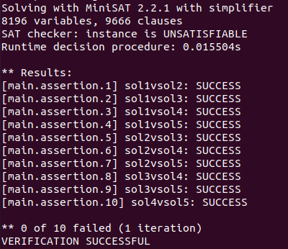

cbmc Problem3.c --unwind 2 --trace

* 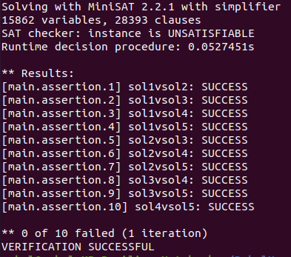

cbmc Problem3.c --unwind 3 --trace

* 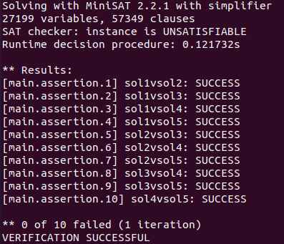

cbmc Problem3.c --unwind 4 --trace

* 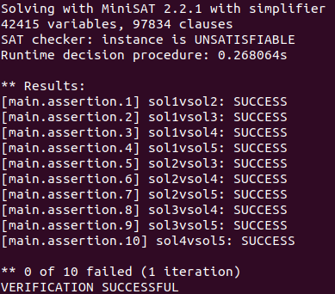

cbmc Problem3.c --unwind 5 --trace

* 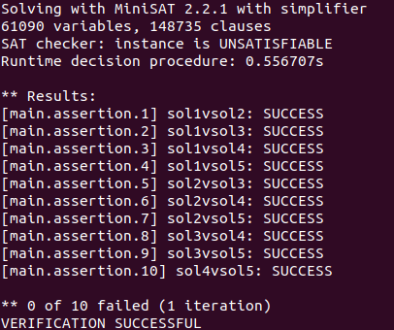

1. **FireAndIce.c**

cbmc FireAndIce.c --unwind 1 --trace

* 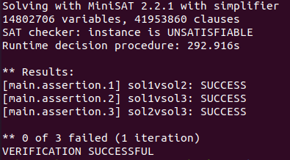

cbmc FireAndIce.c --unwind 2 --trace

* The running takes a very long time which suggests it is Unsatisfiable.

1. **CodeCrazyMinions.c**

cbmc CodeCrazyMinions.c --unwind 1 --trace

* 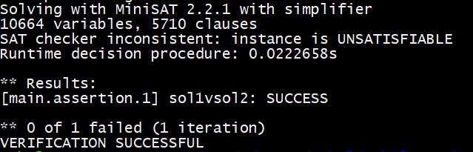

cbmc CodeCrazyMinions.c --unwind 2 --trace

* 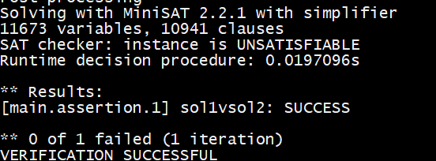

cbmc CodeCrazyMinions.c --unwind 3 --trace

* 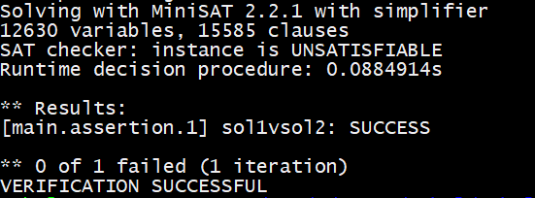

cbmc CodeCrazyMinions.c --unwind 4 --trace

* 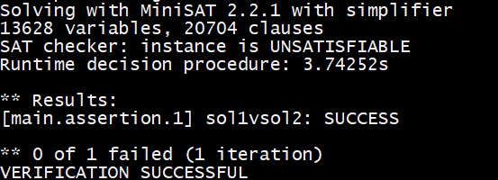

cbmc CodeCrazyMinions.c -- unwind 5 --trace

* 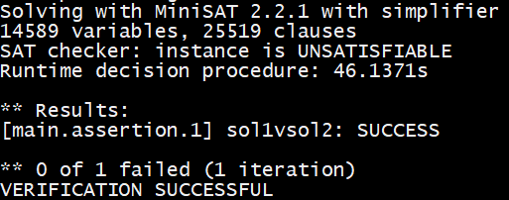

cbmc CodeCrazyMinions.c -- unwind 10 --trace

* The running takes a very long time which suggests it is Unsatisfiable.

1. **DistinctCode1.c**

cbmc DistinctCode1.c --unwind 1 --trace

* 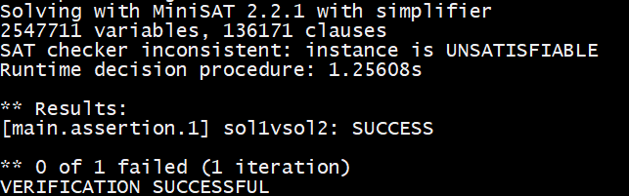

cbmc DistinctCode1.c --unwind 2 --trace

* 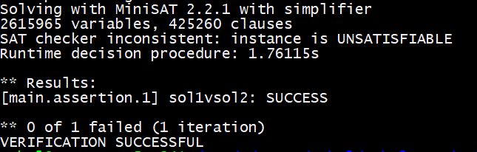

cbmc DistinctCode1.c --unwind 3 --trace

* 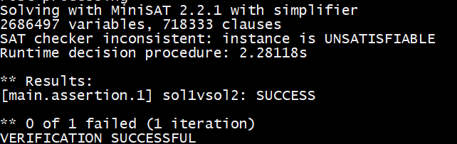

cbmc DistinctCode1.c --unwind 4 --trace

* 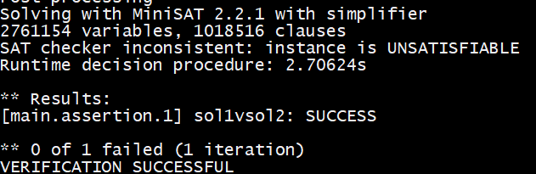

cbmc DistinctCode1.c --unwind 5 --trace

* 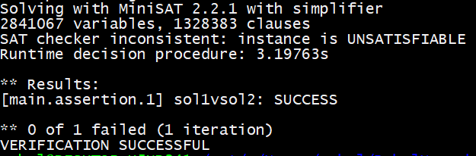

cbmc DistinctCode1.c --unwind 10 --trace

* 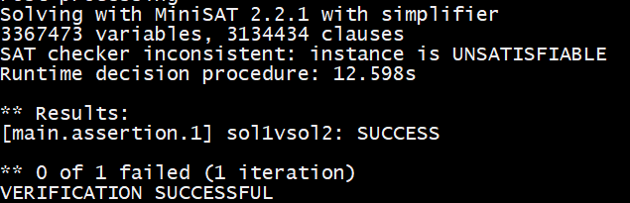

1. **TestingRobot.c**

cbmc TestingRobot.c --unwind 1 --trace

* 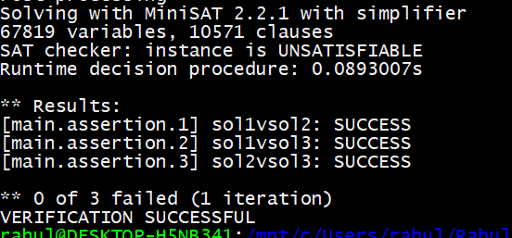

cbmc TestingRobot.c --unwind 2 --trace

* 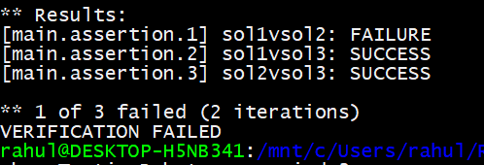

Violated property:

file TestingRobot.c line 107 function main

sol1vsol2

return_value_sol1 == return_value_sol2

** 1 of 3 failed (2 iterations)

VERIFICATION FAILED

cbmc TestingRobot.c --unwind 3 --trace

* 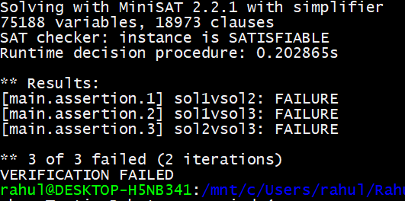

Assertion 1:

Violated property:

file TestingRobot.c line 107 function main

sol1vsol2

return_value_sol1 == return_value_sol2

Assertion 2:

Violated property:

file TestingRobot.c line 107 function main

sol1vsol2

return_value_sol1 == return_value_sol2

Violated property:

file TestingRobot.c line 108 function main

sol1vsol3

return_value_sol1$0 == return_value_sol3

Assertion 3:

Violated property:

file TestingRobot.c line 107 function main

sol1vsol2

return_value_sol1 == return_value_sol2

Violated property:

file TestingRobot.c line 109 function main

sol2vsol3

return_value_sol2$0 == return_value_sol3$0

** 3 of 3 failed (2 iterations)

VERIFICATION FAILED

All the examples failed. This means none of the solutions is equivalent to each other

Print of –trace

1. **ThreeLetters.c**

cbmc ThreeLetters.c --unwind 1

* 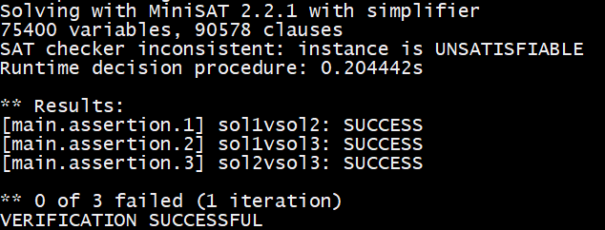

cbmc ThreeLetters.c --unwind 2

* 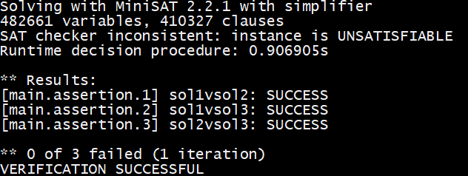

cbmc ThreeLetters.c --unwind 3

* 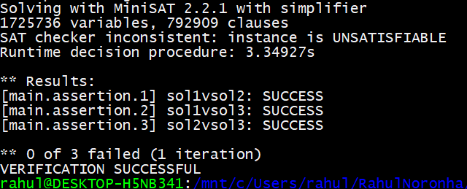

cbmc ThreeLetters.c --unwind 4

* 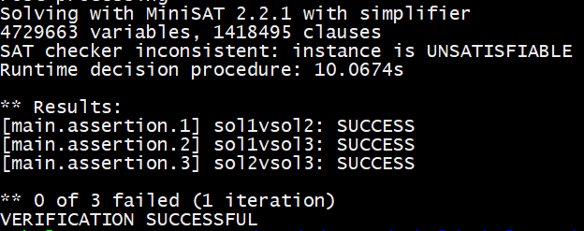

cbmc ThreeLetters.c --unwind 5

* 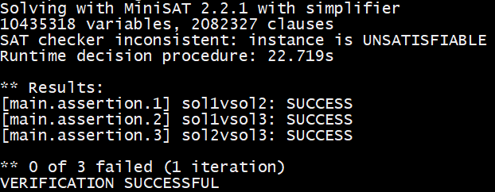

cbmc ThreeLetters.c --unwind 10

* Time limit exceeded which suggests unsatisfiability.

1. **LastDigitSum.c**

cbmc LastDigitSum.c --unwind 1

* 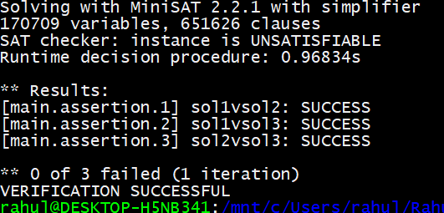

cbmc LastDigitSum.c --unwind 2

* 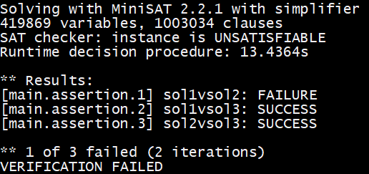

cbmc LastDigitSum.c --unwind 2 --trace

* 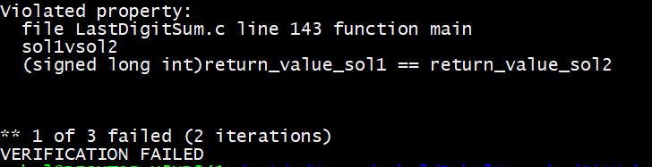

Trace:

Violated property:

file LastDigitSum.c line 143 function main

sol1vsol2

(signed long int)return_value_sol1 == return_value_sol2

1. **ChefAndModuloGame.c**

cbmc ChefAndModuloGame.c --unwind 1

* 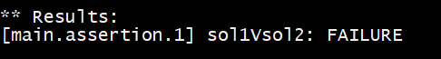
* 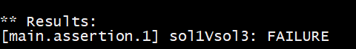
* 

Violated property:

file ChefAndModuloGame.c line 108 function main

sol1Vsol2

return_value_sol1 == return_value_sol2

** 1 of 1 failed (1 iteration)

VERIFICATION FAILED

Violated property:

file ChefAndModuloGame.c line 109 function main

sol1Vsol3

return_value_sol1 == return_value_sol3

** 1 of 1 failed (1 iteration)

VERIFICATION FAILED

Violated property:

file ChefAndModuloGame.c line 110 function main

sol1Vsol4

return_value_sol1 == return_value_sol4

** 1 of 1 failed (1 iteration)

VERIFICATION FAILED

1. **AndOperation.c**

cbmc AndOperation.c --unwind 1

* 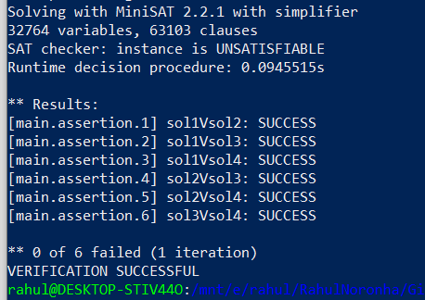

cbmc AndOperation.c --unwind 2

* 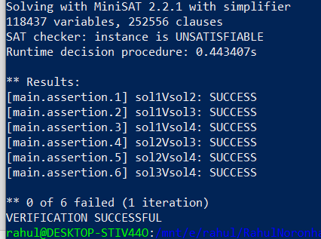

cbmc AndOperation.c --unwind 3

* 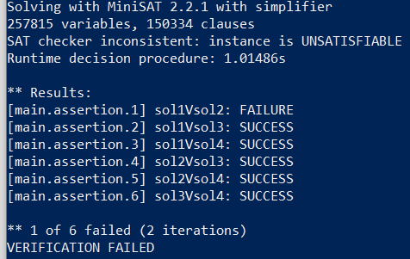

--trace used to produce the trace of the counterexample

Trace for main.assertion.1:

Violated property:

file AndOperation.c line 144 function main

sol1Vsol2

return_value_sol1 == return_value_sol2

1. **ChefIsJustThrowingRandomWords.c**

cbmc ChefIsJustThrowingRandomWords.c --unwind 1

* 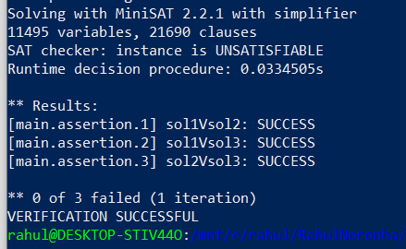

cbmc ChefIsJustThrowingRandomWords.c --unwind 2

* 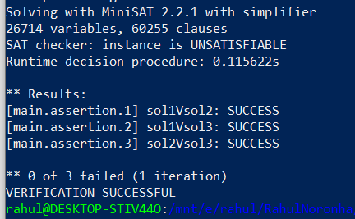

cbmc ChefIsJustThrowingRandomWords.c --unwind 3

* 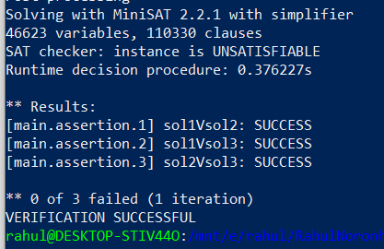

cbmc ChefIsJustThrowingRandomWords.c --unwind 4

* 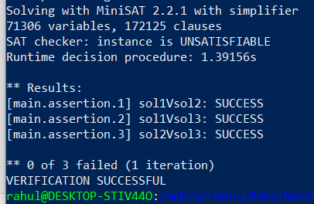

cbmc ChefIsJustThrowingRandomWords.c --unwind 5

* 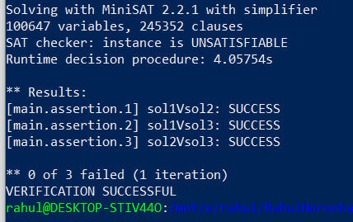

cbmc ChefIsJustThrowingRandomWords.c --unwind 10

* Time exceeded.

1. **ClimbingStairs.c**

cbmc ClimbingStairs.c --unwind 1

* Time exceeded so we assume it is unsatisfiable and that no counterexample was found.

1. **ChefAndSquares.c**

cbmc ChefAndSquares.c --unwind 1

* 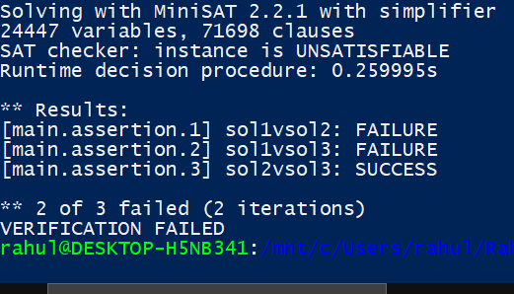

--trace

Trace for main.assertion.1:

Violated property:

file ChefAndSquares.c line 84 function main

sol1vsol2

return_value_sol1 == return_value_sol2

Trace for main.assertion.2:

Violated property:

file ChefAndSquares.c line 84 function main

sol1vsol2

return_value_sol1 == return_value_sol2

Violated property:

file ChefAndSquares.c line 85 function main

sol1vsol3

return_value_sol1$0 == return_value_sol3

1. **ChefAndString.c**

cbmc ChefAndString.c --unwind 1

* 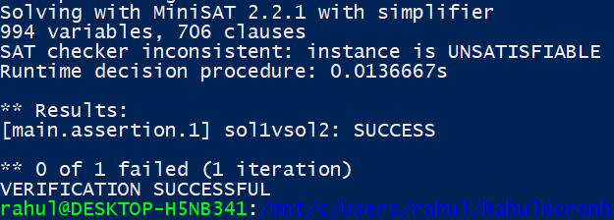

cbmc ChefAndString.c --unwind 2

* 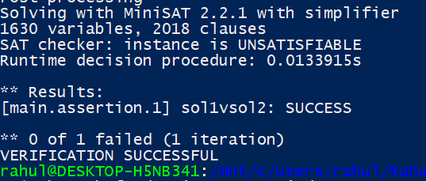

cbmc ChefAndString.c --unwind 3

* 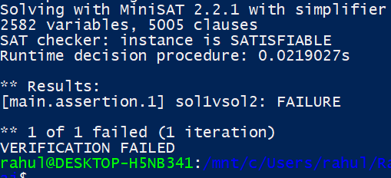

--trace

** Results:

[main.assertion.1] sol1vsol2: FAILURE

Trace for main.assertion.1:

Violated property:

file ChefAndString.c line 66 function main

sol1vsol2

return_value_sol1 == return_value_sol2

** 1 of 1 failed (1 iteration)

VERIFICATION FAILED

1. **SimilarityNumber.c**

cbmc SimilarityNumber.c --unwind 1

* 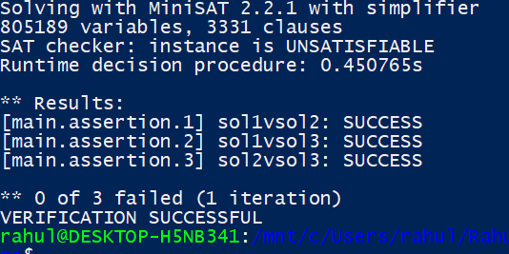

cbmc SimilarityNumber.c --unwind 2

* 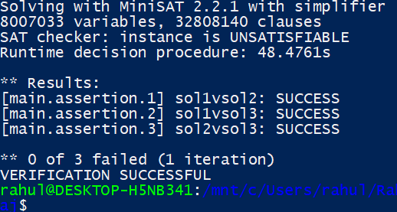

cbmc SimilarityNumber.c --unwind 3

* Time exceeded so we assume it is unsatisfiable and that no counterexample was found.

1. **SmallVolume.c**

cbmc SmallVolume.c --unwind 1

* Time exceeded so we assume it is unsatisfiable and that no counterexample was found

1. **Marbles.c**

cbmc Marbles.c --unwind 1

* 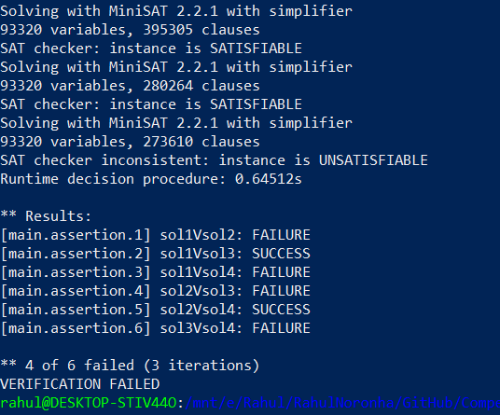

cbmc Marbles.c --unwind 1 --trace

Trace for main.assertion.1:

Violated property:

file Marbles.c line 107 function main

sol1Vsol2

return_value_sol1 == return_value_sol2

Trace for main.assertion.3:

Violated property:

file Marbles.c line 107 function main

sol1Vsol2

return_value_sol1 == return_value_sol2

Violated property:

file Marbles.c line 109 function main

sol1Vsol4

return_value_sol1$1 == return_value_sol4

Trace for main.assertion.4:

Violated property:

file Marbles.c line 107 function main

sol1Vsol2

return_value_sol1 == return_value_sol2

Violated property:

file Marbles.c line 109 function main

sol1Vsol4

return_value_sol1$1 == return_value_sol4

Violated property:

file Marbles.c line 110 function main

sol2Vsol3

return_value_sol2$0 == return_value_sol3$0

Trace for main.assertion.6:

Violated property:

file Marbles.c line 107 function main

sol1Vsol2

return_value_sol1 == return_value_sol2

Violated property:

file Marbles.c line 110 function main

sol2Vsol3

return_value_sol2$0 == return_value_sol3$0

Violated property:

file Marbles.c line 112 function main

sol3Vsol4

return_value_sol3$1 == return_value_sol4$1

** 4 of 6 failed (3 iterations)

VERIFICATION FAILED

1. **PhysicsClass.c**

cbmc PhysicsClass.c --unwind 1

* Time exceeded so we assume it is unsatisfiable and that no counterexample was found

1. **Player.c**

cbmc Player.c --unwind 1

* Time exceeded so we assume it is unsatisfiable and that no counterexample was found

1. **RacingHorses.c**

cbmc RacingHorses.c --unwind 1

* Time exceeded so we assume it is unsatisfiable and that no counterexample was found

1. **UncleJohny.c**

cbmc UncleJohny.c --unwind 1

* Time exceeded so we assume it is unsatisfiable and that no counterexample was found

1. **TheTomAndJerryGame!.c**

cbmc 'TheTomAndJerryGame!.c' --unwind 1

* 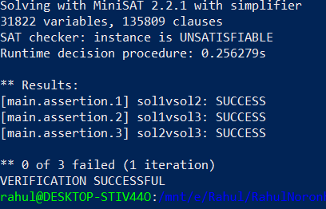

cbmc 'TheTomAndJerryGame!.c' --unwind 2

* 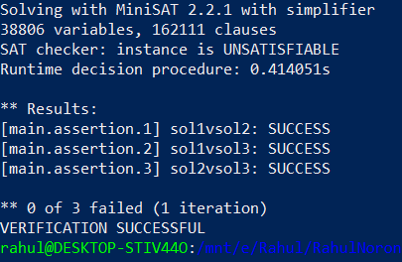

cbmc 'TheTomAndJerryGame!.c' --unwind 3

* 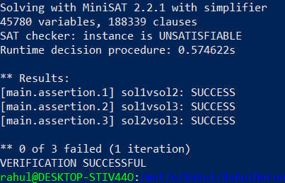

cbmc 'TheTomAndJerryGame!.c' --unwind 4

* 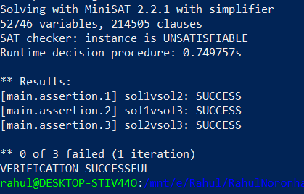

cbmc 'TheTomAndJerryGame!.c' --unwind 5

* 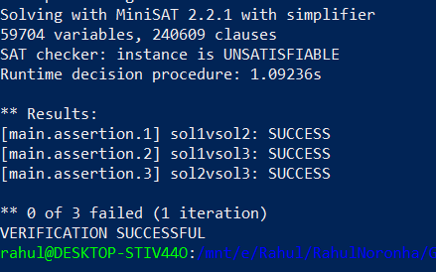

cbmc 'TheTomAndJerryGame!.c' --unwind 10

* 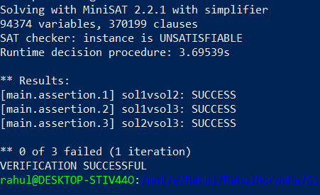

1. **MaximumCandies.c**

cbmc MaximumCandies.c --unwind 1

* 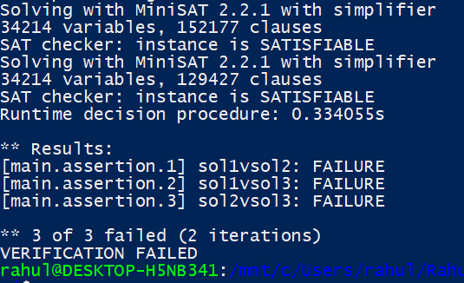

cbmc MaximumCandies.c --unwind 1 --trace

Trace for main.assertion.1:

Violated property:

file MaximumCandies.c line 142 function main

sol1vsol2

return_value_sol1 == return_value_sol2

Trace for main.assertion.2:

Violated property:

file MaximumCandies.c line 143 function main

sol1vsol3

return_value_sol1$0 == return_value_sol3

Trace for main.assertion.3:

Violated property:

file MaximumCandies.c line 144 function main

sol2vsol3

return_value_sol2$0 == return_value_sol3$0

** 3 of 3 failed (2 iterations)

VERIFICATION FAILED

1. **ChefAndFruits.c**

cbmc ChefAndFruits.c --unwind 1

* 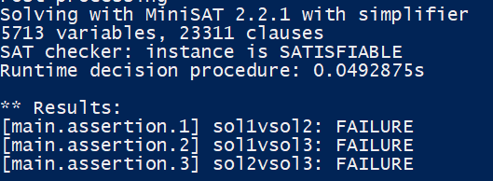

cbmc ChefAndFruits.c --unwind 1 --trace

Trace for main.assertion.1:

Violated property:

file ChefAndFruits.c line 79 function main

sol1vsol2

return_value_sol1 == return_value_sol2

Trace for main.assertion.2:

Violated property:

file ChefAndFruits.c line 80 function main

sol1vsol3

return_value_sol1$0 == return_value_sol3

Trace for main.assertion.3:

Violated property:

file ChefAndFruits.c line 81 function main

sol2vsol3

return_value_sol2$0 == return_value_sol3$0

** 3 of 3 failed (1 iteration)

VERIFICATION FAILED

1. **MaximumCandies2.c**

cbmc MaximumCandies2.c --unwind 1

* 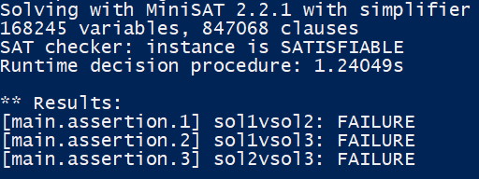

cbmc MaximumCandies2.c --unwind 1 –trace

Trace for main.assertion.1:

Violated property:

file MaximumCandies2.c line 107 function main

sol1vsol2

return_value_sol1 == return_value_sol2

Trace for main.assertion.2:

Violated property:

file MaximumCandies2.c line 108 function main

sol1vsol3

(signed long int)return_value_sol1$0 == return_value_sol3

Trace for main.assertion.3:

Violated property:

file MaximumCandies2.c line 109 function main

sol2vsol3

(signed long int)return_value_sol2$0 == return_value_sol3$0

1. **ChefAndChocolate.c**

cbmc ChefAndChocolate.c --unwind 1

* 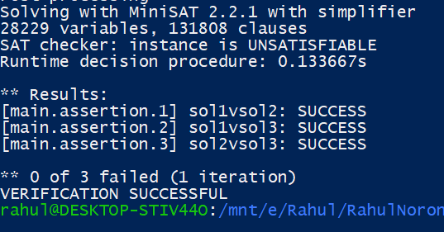

cbmc ChefAndChocolate.c --unwind 2

* 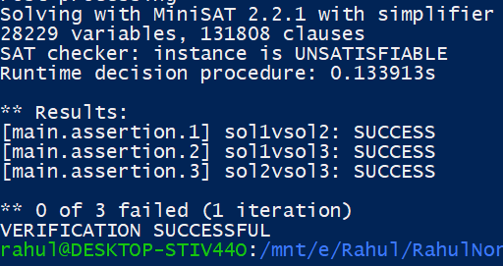

cbmc ChefAndChocolate.c --unwind 3

* 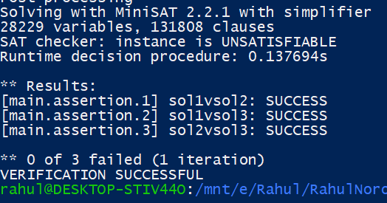

cbmc ChefAndChocolate.c --unwind 4

* 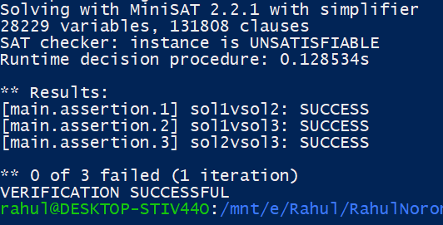

cbmc ChefAndChocolate.c --unwind 5

* 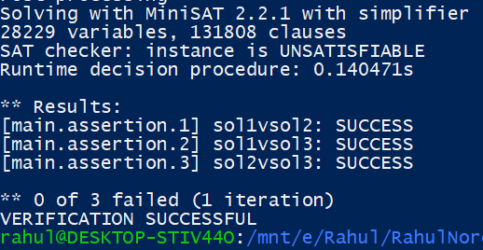

cbmc ChefAndChocolate.c --unwind 10

* 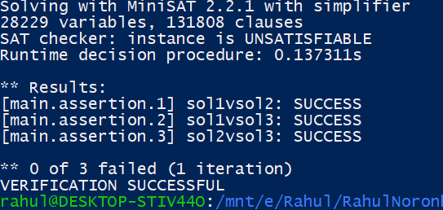

1. **ChefAndBoardGames.c**

cbmc ChefAndBoardGames.c --unwind 1

* 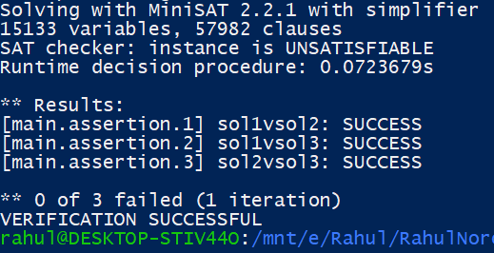

cbmc ChefAndBoardGames.c --unwind 2

* 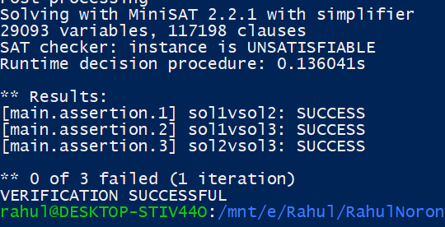

cbmc ChefAndBoardGames.c --unwind 3

* 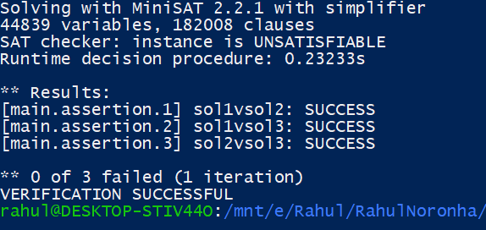

cbmc ChefAndBoardGames.c --unwind 4

* 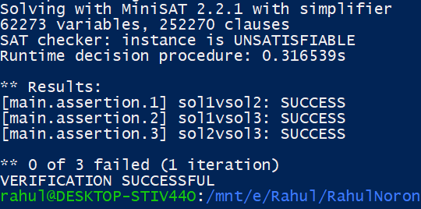

cbmc ChefAndBoardGames.c --unwind 5

* 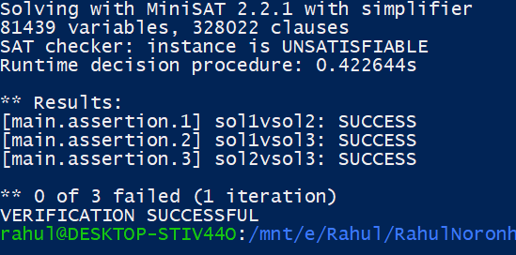

cbmc ChefAndBoardGames.c --unwind 10

* 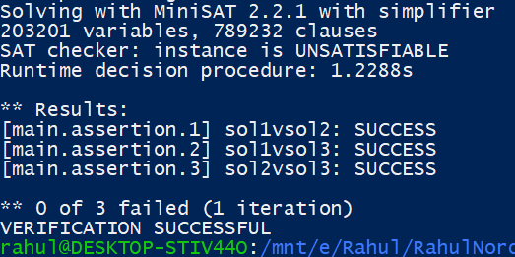

1. **ChefAndInterview.c**

cbmc ChefAndInterview.c --unwind 1

* 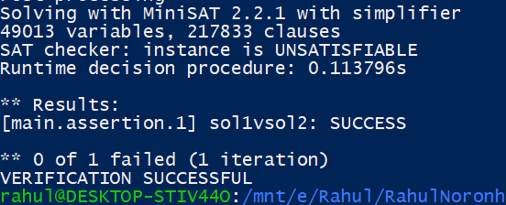

cbmc ChefAndInterview.c --unwind 2

* 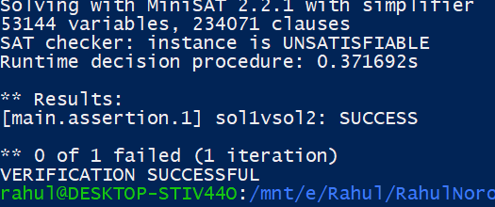

cbmc ChefAndInterview.c --unwind 3

* 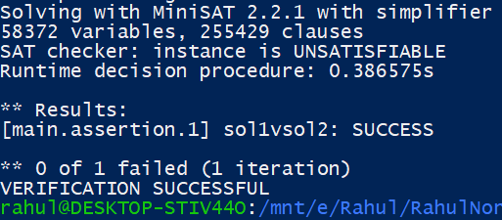

cbmc ChefAndInterview.c --unwind 4

* 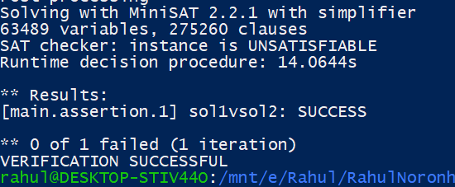

cbmc ChefAndInterview.c --unwind 5

* 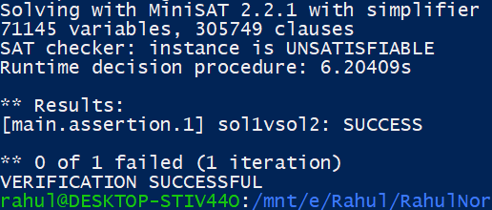

cbmc ChefAndInterview.c --unwind 10

* 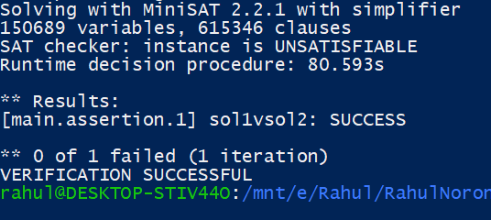

1. **ChangAndThePerfectFunction.c**

cbmc ChangAndThePerfectFunction.c --unwind 1

* 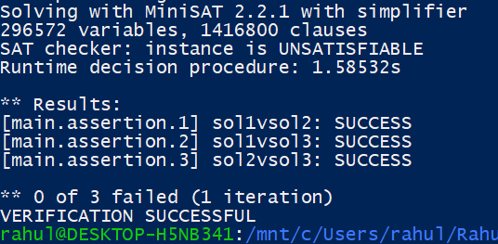

cbmc ChangAndThePerfectFunction.c --unwind 2

* 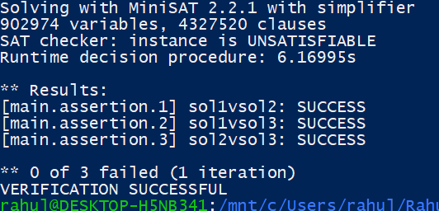

cbmc ChangAndThePerfectFunction.c --unwind 3

* 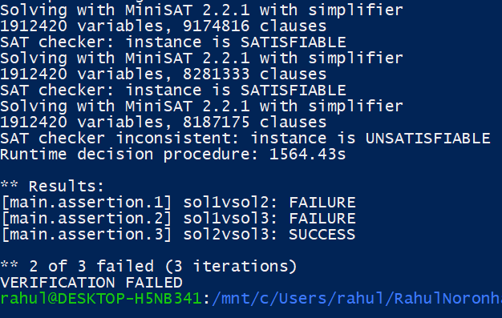

cbmc ChangAndThePerfectFunction.c --unwind 3 --trace

Violated property:

file ChangAndThePerfectFunction.c line 84 function main

sol1vsol2

(signed long int)return_value_sol1 == return_value_sol2

Violated property:

file ChangAndThePerfectFunction.c line 85 function main

sol1vsol3

(signed long int)return_value_sol1$0 == return_value_sol3

** 2 of 3 failed (3 iterations)

VERIFICATION FAILED

1. **ABigSale.c**

cbmc ABigSale.c --uniwind 1

* 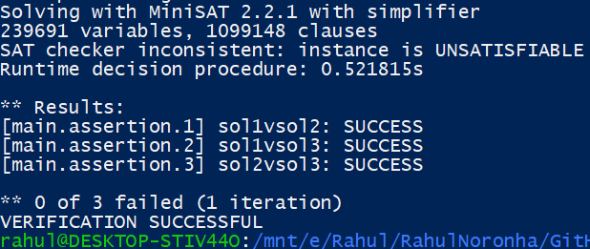

cbmc ABigSale.c --uniwind 2

* 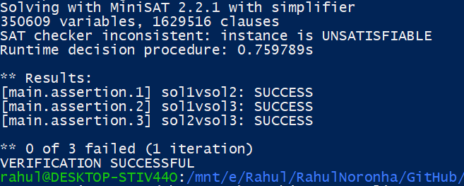

cbmc ABigSale.c --uniwind 3

* 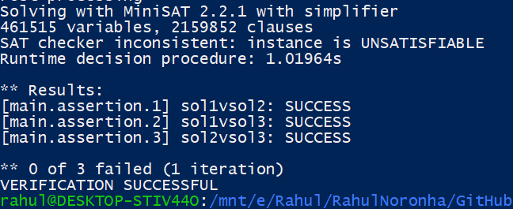

cbmc ABigSale.c --uniwind 4

* 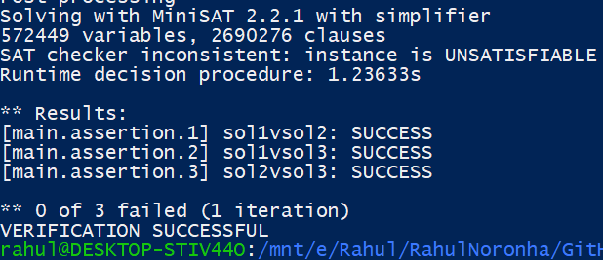

cbmc ABigSale.c --uniwind 5

* 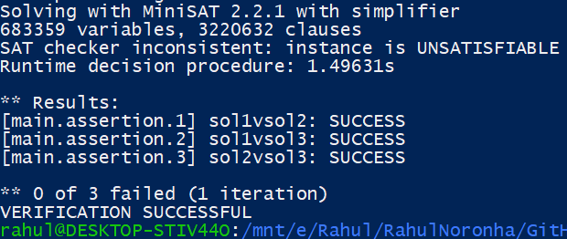

cbmc ABigSale.c --uniwind 10

* 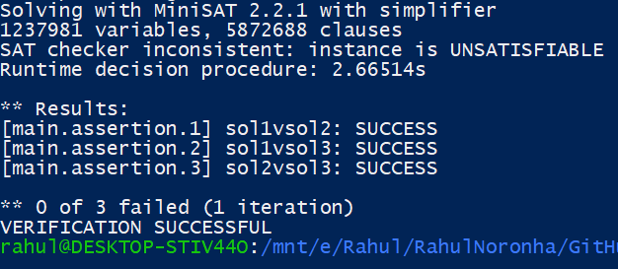

1. **Factorial.c**

cbmc Factorial.c --uniwind 1

* 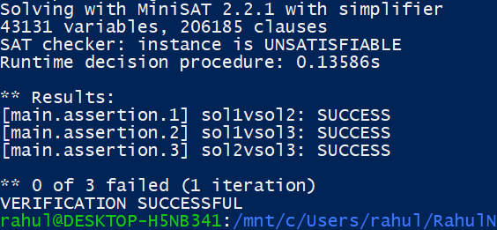

cbmc Factorial.c --uniwind 2

* 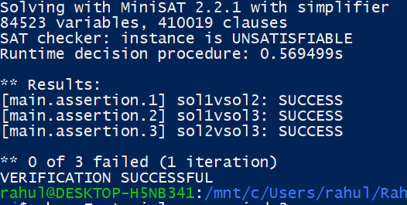

cbmc Factorial.c --uniwind 3

* 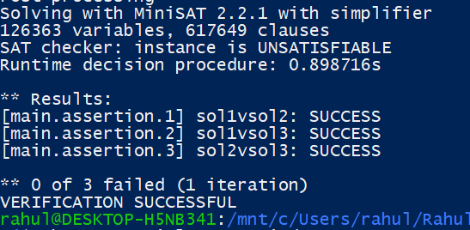

cbmc Factorial.c --uniwind 4

* 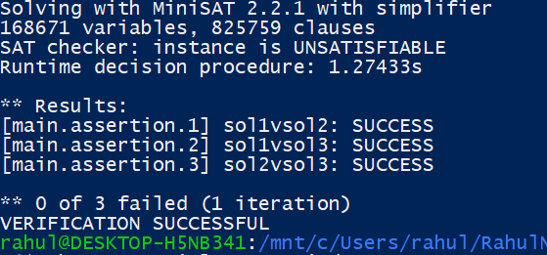

cbmc Factorial.c --uniwind 5

* 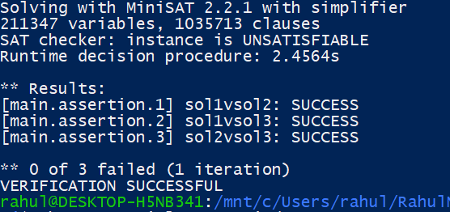

cbmc Factorial.c --uniwind 10

* Time exceeded so we assume it is unsatisfiable and that no counterexample was found

1. **CoinFlip.c**

cbmc CoinFlip.c --unwind 1

* 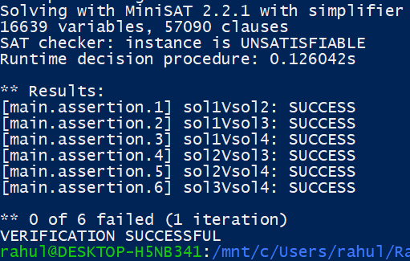

cbmc CoinFlip.c --unwind 2

* 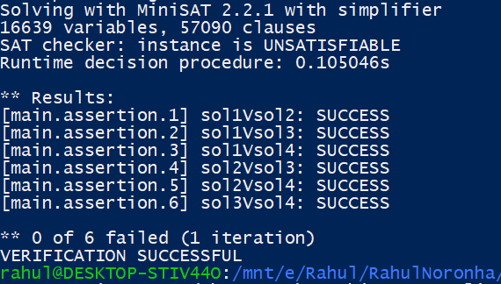

cbmc CoinFlip.c --unwind 3

* 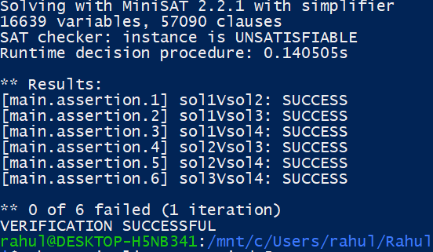

cbmc CoinFlip.c --unwind 4

* 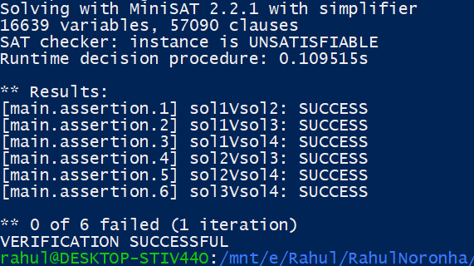

cbmc CoinFlip.c --unwind 5

* 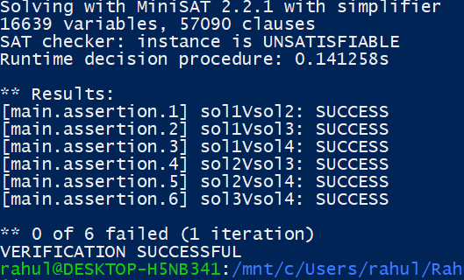

cbmc CoinFlip.c --unwind 10

* 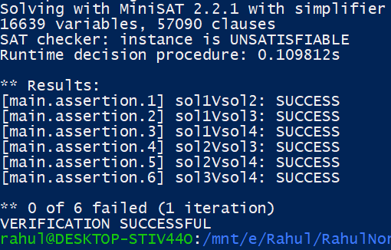

1. **Caravans.c**

cbmc Caravans.c --unwind 1

* 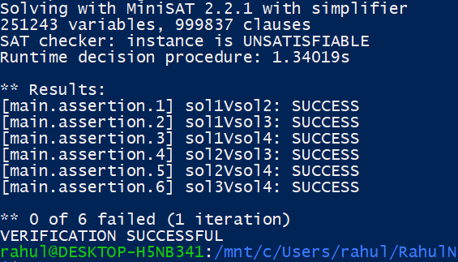

cbmc Caravans.c --unwind 2

* 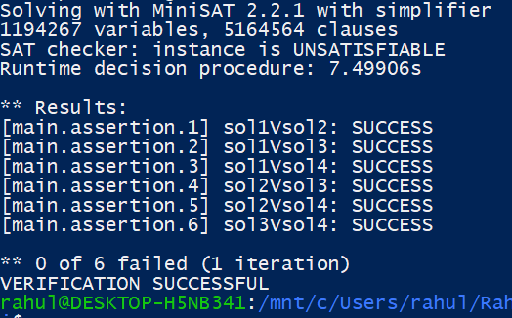

cbmc Caravans.c --unwind 3

* 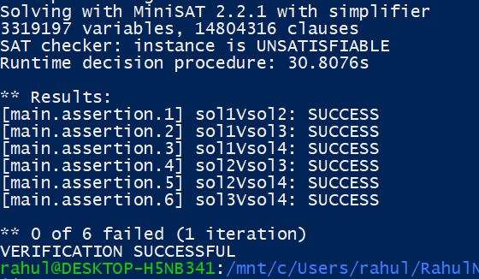

cbmc Caravans.c --unwind 4

* 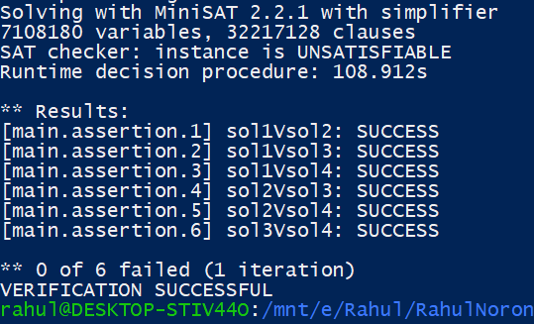

cbmc Caravans.c --unwind 5

* 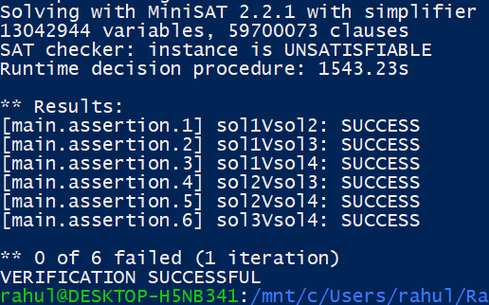

cbmc Caravans.c --unwind 10

* Time limit exceeded. Assume it is unsatisfiable.

1. **CountingSubs.c**

cbmc CountingSubs.c --unwind 1

* 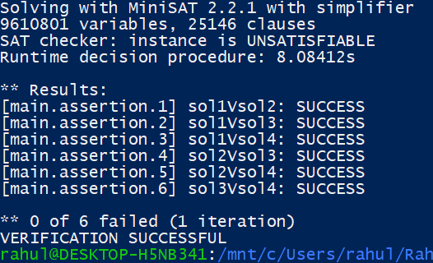

cbmc CountingSubs.c --unwind 2

* 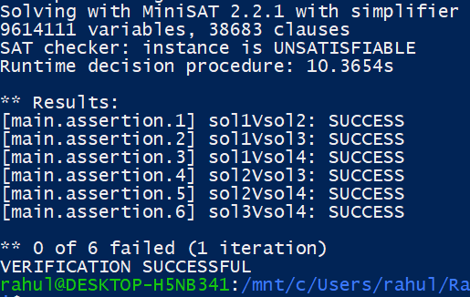

cbmc CountingSubs.c --unwind 3

* 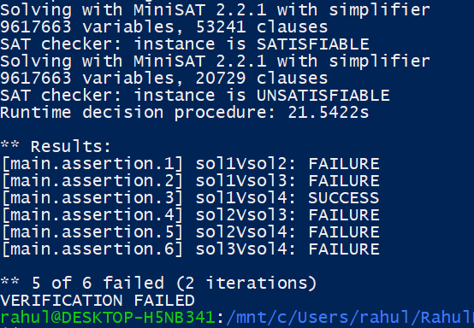

cbmc CountingSubs.c --unwind 3 --trace

Violated property:

file CountingSubs.c line 96 function main

sol1Vsol2

return_value_sol1 == return_value_sol2

Violated property:

file CountingSubs.c line 97 function main

sol1Vsol3

return_value_sol1 == return_value_sol3

Violated property:

file CountingSubs.c line 99 function main

sol2Vsol3

return_value_sol2 == return_value_sol3

Violated property:

file CountingSubs.c line 100 function main

sol2Vsol4

return_value_sol2 == return_value_sol4

Violated property:

file CountingSubs.c line 101 function main

sol3Vsol4

return_value_sol3 == return_value_sol4

1. **PayingUp.c**

cbmc PayingUp.c --unwind 1

* 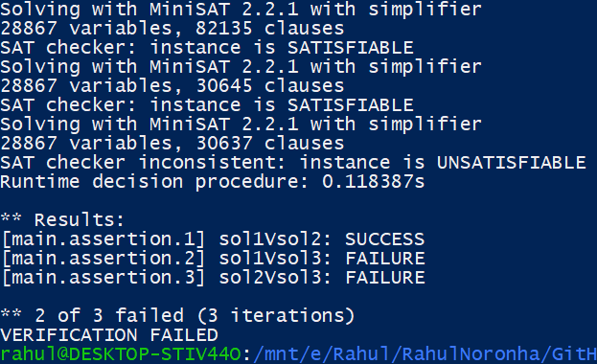

cbmc PayingUp.c --unwind 1 --trace

Violated property:

file PayingUp.c line 102 function main

sol1Vsol3

return_value_sol1$0 == return_value_sol3

Violated property:

file PayingUp.c line 103 function main

sol2Vsol3

return_value_sol2$0 == return_value_sol3$0

** 2 of 3 failed (3 iterations)

VERIFICATION FAILED

1. **JewelsAndStones.c**

cbmc JewelsAndStones.c -- unwind 1

* 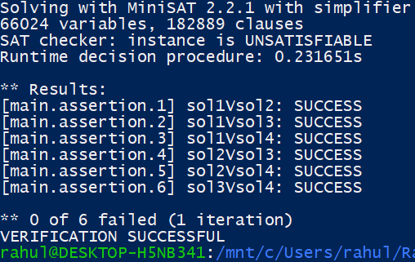

cbmc JewelsAndStones.c -- unwind 2

* 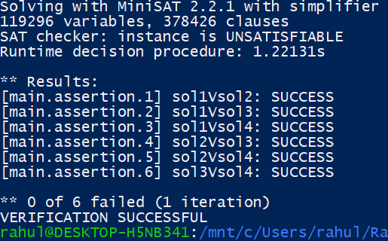

cbmc JewelsAndStones.c -- unwind 3

* 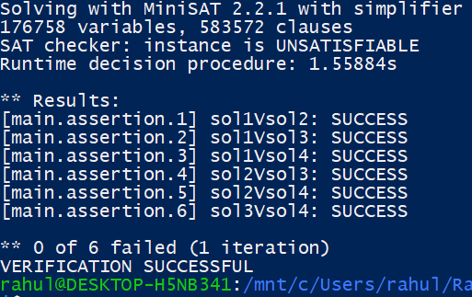

cbmc JewelsAndStones.c -- unwind 4

* 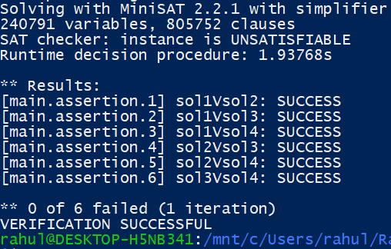

cbmc JewelsAndStones.c -- unwind 5

* 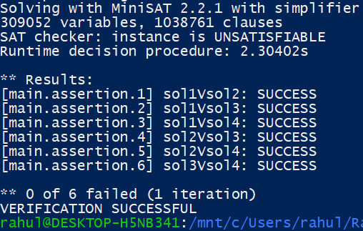

cbmc JewelsAndStones.c -- unwind 10

* 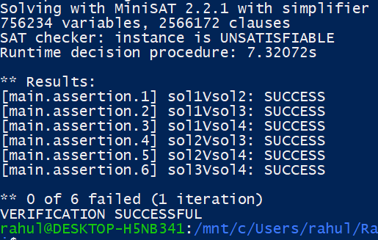

1. **ChefAndDemonetisation.c**

cbmc ChefAndDemonetisation.c --unwind 1

* Time exceeded so assume it it Unsatisfiable.

1. **ChefAndStrangeFormula.c**

cbmc ChefAndStrangeFormula.c --unwind 1

* 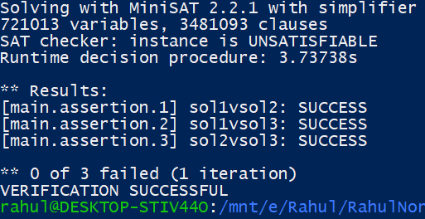

cbmc ChefAndStrangeFormula.c --unwind 2

* 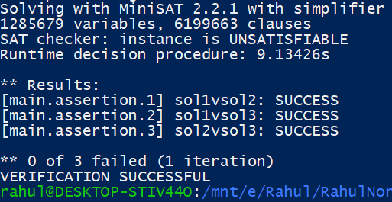

cbmc ChefAndStrangeFormula.c --unwind 3

* 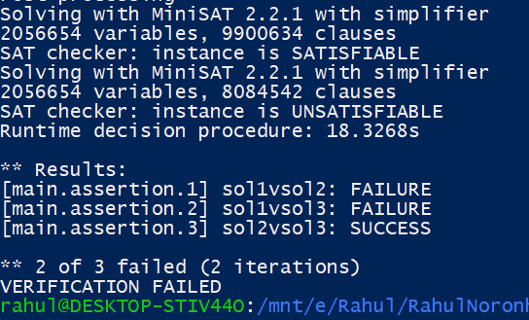

cbmc ChefAndStrangeFormula.c --unwind 3 --trace

Trace for main.assertion.1:

Violated property:

file ChefAndStrangeFormula.c line 107 function main

sol1vsol2

return_value_sol1 == return_value_sol2

Trace for main.assertion.2:

Violated property:

file ChefAndStrangeFormula.c line 108 function main

sol1vsol3

return_value_sol1$0 == return_value_sol3

** 2 of 3 failed (2 iterations)

VERIFICATION FAILED

1. **ChefAndDifficultContests.c**

cbmc ChefAndDifficultContests.c --unwind 1

* 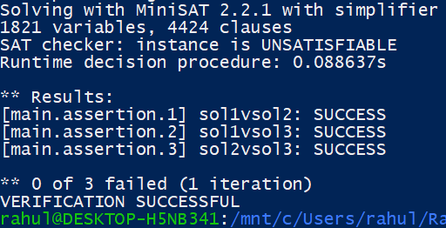

cbmc ChefAndDifficultContests.c --unwind 2

* 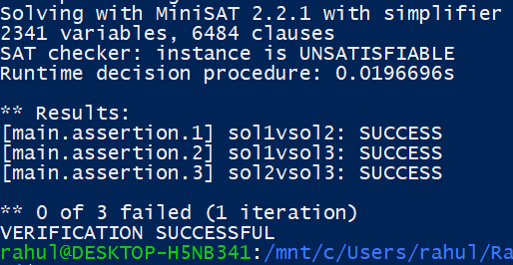

cbmc ChefAndDifficultContests.c --unwind 3

* 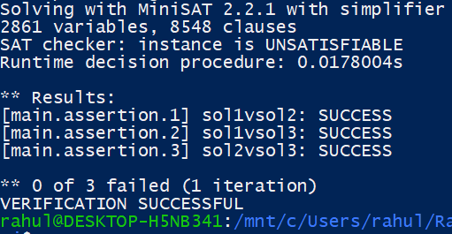

cbmc ChefAndDifficultContests.c --unwind 4

* 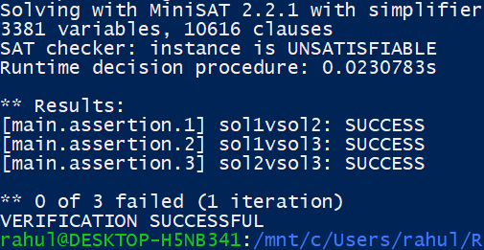

cbmc ChefAndDifficultContests.c --unwind 5

* 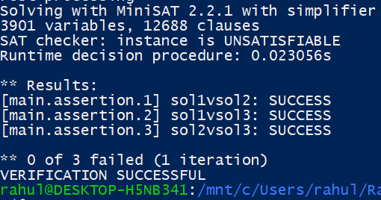

cbmc ChefAndDifficultContests.c --unwind 10

* 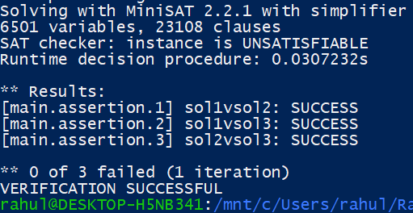

1. **DistributeApples2.c**

cbmc DistributeApples2.c --unwind 1

* 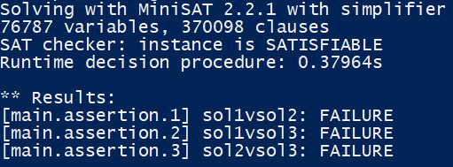

cbmc DistributeApples2.c --unwind 1 --trace

Violated property:

file DistributeApples2.c line 62 function main

sol1vsol2

return_value_sol1 == return_value_sol2

Violated property:

file DistributeApples2.c line 63 function main

sol1vsol3

return_value_sol1$0 == (signed long int)return_value_sol3

Violated property:

file DistributeApples2.c line 64 function main

sol2vsol3

return_value_sol2$0 == (signed long int)return_value_sol3$0

** 3 of 3 failed (1 iteration)

VERIFICATION FAILED

1. **ChefAndFeedback.c**

cbmc ChefAndFeedback.c --unwind 1

* 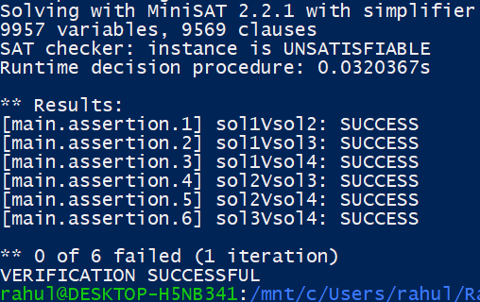

cbmc ChefAndFeedback.c --unwind 2

* 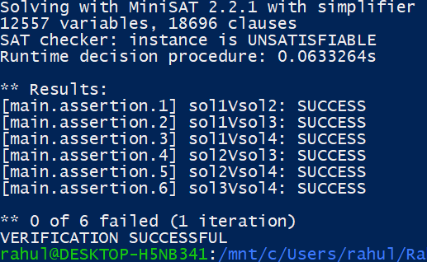

cbmc ChefAndFeedback.c --unwind 3

* 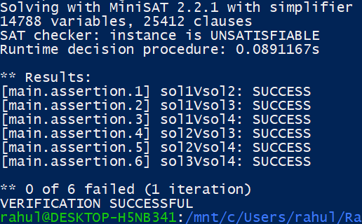

cbmc ChefAndFeedback.c --unwind 4

* 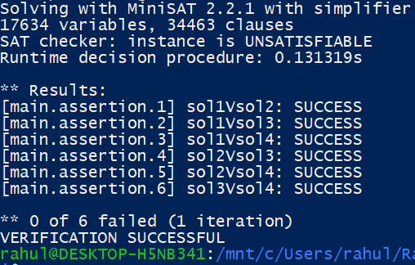

cbmc ChefAndFeedback.c --unwind 5

* 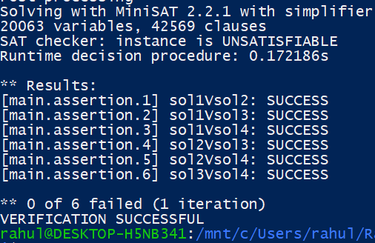

cbmc ChefAndFeedback.c --unwind 10

* 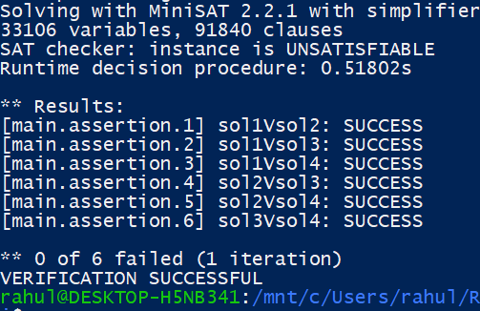

1. **Chopsticks.c**

cbmc Chopsticks.c --unwind 1

* Time limit exceeded, so we assume it is unsatisfiable.

1. MaximizeProduct.c

cbmc MaximizeProduct.c -- unwind 1

* 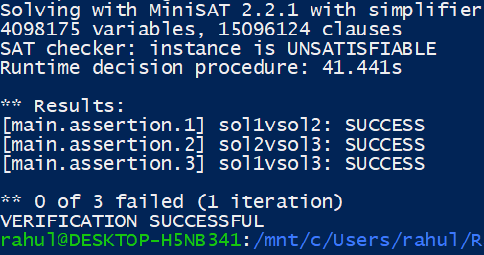

cbmc MaximizeProduct.c -- unwind 2

* Time exceeded so assume it is Unsatisfiable.

1. **MinimumAndMaximum.c**

cbmc MinimumAndMaximum.c -- unwind 1

* 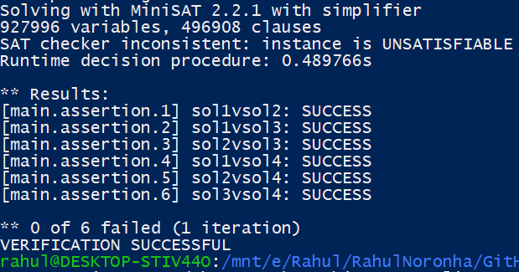

cbmc MinimumAndMaximum.c -- unwind 2

* 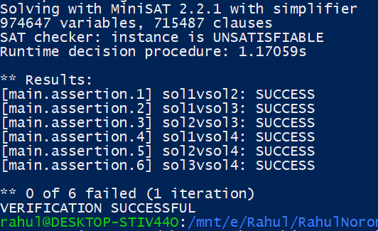

cbmc MinimumAndMaximum.c -- unwind 3

* Time exceeded so assume it is Unsatisfiable.

1. **ChefAndTuples.c**

cbmc ChefAndTuples.c -- unwind 1

* 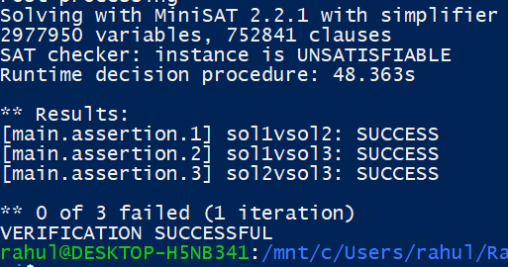

cbmc ChefAndTuples.c -- unwind 2

* 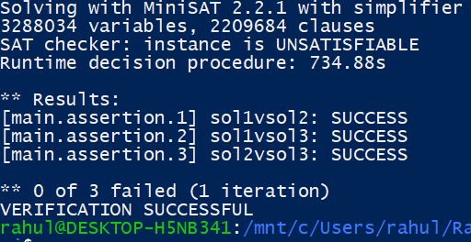

cbmc ChefAndTuples.c -- unwind 3

* Time exceeded so assume it is Unsatisfiable.

1. **MaximizeProduct.c**

cbmc MaximizeProduct.c --unwind 1

* 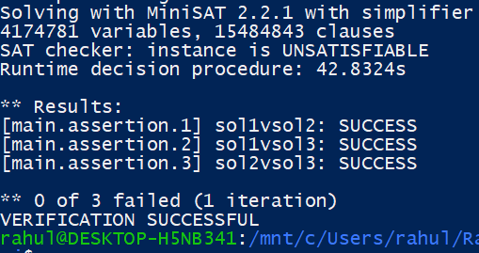

cbmc MaximizeProduct.c --unwind 2

* Time exceeded, so assume it is unsatisfiable.

1. **ChefAndBipartiteGraphs.c**

cbmc ChefAndBipartiteGraphs.c -- unwind 1

* 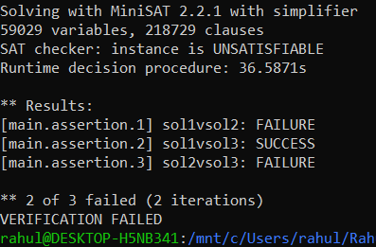

cbmc ChefAndBipartiteGraphs.c -- unwind 1 -- trace

Trace for main.assertion.1:

Violated property:

file ChefAndBipartiteGraphs.c line 85 function main

sol1vsol2

return_value_sol1 == return_value_sol2

Trace for main.assertion.3:

Violated property:

file ChefAndBipartiteGraphs.c line 87 function main

sol2vsol3

return_value_sol2$0 == return_value_sol3$0

** 2 of 3 failed (2 iterations)

VERIFICATION FAILED

1. **DivisionCheck.c**

cbmc DivisionCheck.c --unwind 1

* Assume it is unsatisfiable since time limit was exceeded.

1. **ConnectingSoldiers.c**

cbmc ConnectingSoldiers.c -- unwind 1

* 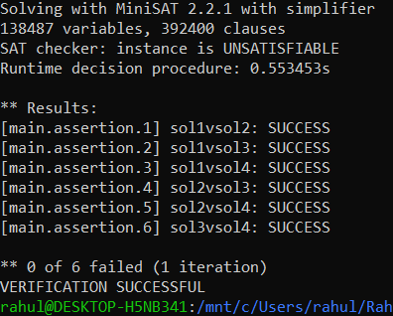

cbmc ConnectingSoldiers.c -- unwind 2

* 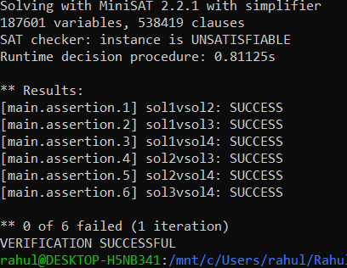

cbmc ConnectingSoldiers.c -- unwind 3

* 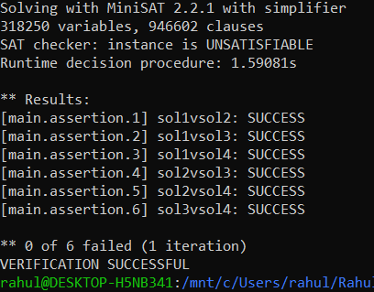

cbmc ConnectingSoldiers.c -- unwind 4

* 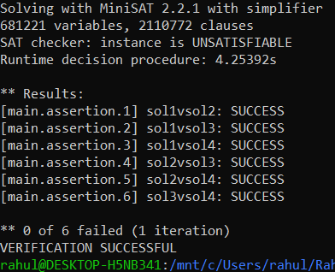

cbmc ConnectingSoldiers.c -- unwind 5

* 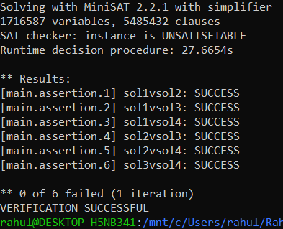

cbmc ConnectingSoldiers.c -- unwind 10

* Time exceeded, so let us assume it is unsatisfiable and that no counterexample is found.

78) **CountingPrettyNumbers.c**

cbmc CountingPrettyNumbers.c -- unwind 1

* 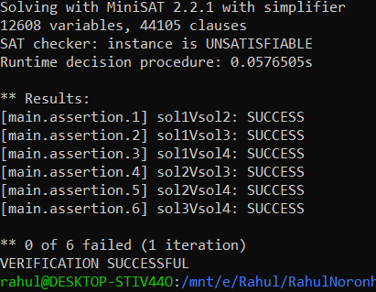

cbmc CountingPrettyNumbers.c -- unwind 2

* 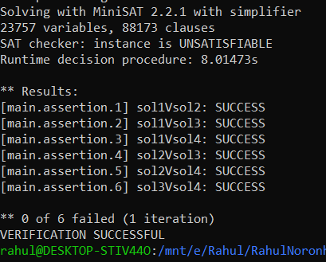

cbmc CountingPrettyNumbers.c -- unwind 3

* 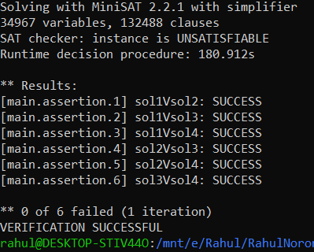

cbmc CountingPrettyNumbers.c -- unwind 4

* 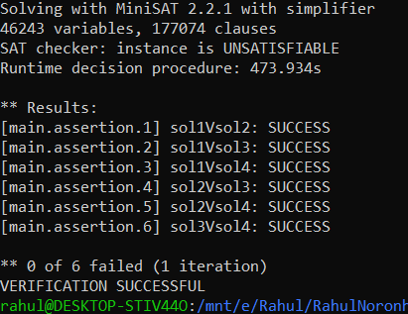

cbmc CountingPrettyNumbers.c -- unwind 5

* 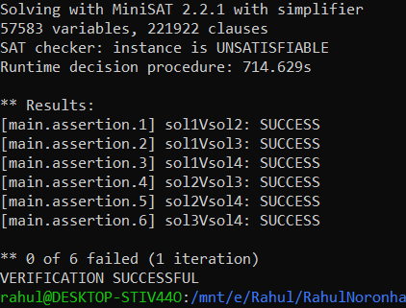

cbmc CountingPrettyNumbers.c -- unwind 10

* Time exceeded, so let us assume it is unsatisfiable and that no counterexample is found.

79) **LittleElephantsAndBombs.c**

cbmc LittleElephantsAndBombs.c -- unwind 1

* 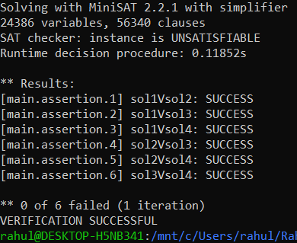

cbmc LittleElephantsAndBombs.c -- unwind 2

* 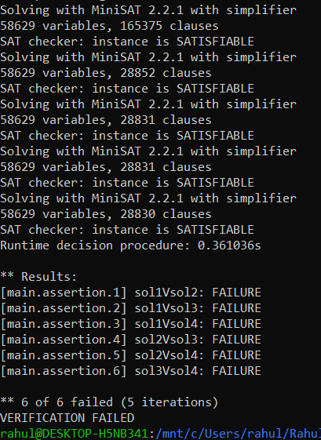

cbmc LittleElephantsAndBombs.c -- unwind 2 --trace

Trace for main.assertion.1:

Violated property:

file LittleElephantsAndBombs.c line 122 function main

sol1Vsol2

return_value_sol1 == return_value_sol2

Trace for main.assertion.2:

Violated property:

file LittleElephantsAndBombs.c line 123 function main

sol1Vsol3

return_value_sol1$0 == return_value_sol3

Trace for main.assertion.3:

Violated property:

file LittleElephantsAndBombs.c line 123 function main

sol1Vsol3

return_value_sol1$0 == return_value_sol3

Violated property:

file LittleElephantsAndBombs.c line 124 function main

sol1Vsol4

return_value_sol1$1 == return_value_sol4

Trace for main.assertion.4:

Violated property:

file LittleElephantsAndBombs.c line 122 function main

sol1Vsol2

return_value_sol1 == return_value_sol2

Violated property:

file LittleElephantsAndBombs.c line 125 function main

sol2Vsol3

return_value_sol2$0 == return_value_sol3$0

Trace for main.assertion.5:

Violated property:

file LittleElephantsAndBombs.c line 124 function main

sol1Vsol4

return_value_sol1$1 == return_value_sol4

Violated property:

file LittleElephantsAndBombs.c line 126 function main

sol2Vsol4

return_value_sol2$1 == return_value_sol4$0

Trace for main.assertion.6:

Violated property:

file LittleElephantsAndBombs.c line 124 function main

sol1Vsol4

return_value_sol1$1 == return_value_sol4

Violated property:

file LittleElephantsAndBombs.c line 126 function main

sol2Vsol4

return_value_sol2$1 == return_value_sol4$0

Violated property:

file LittleElephantsAndBombs.c line 127 function main

sol3Vsol4

return_value_sol3$1 == return_value_sol4$1

** 6 of 6 failed (5 iterations)

VERIFICATION FAILED

80) **MagicPairs.c**

Bruteforce: Successful and prints no counterexample

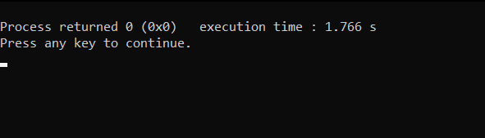

cbmc MagicPairs.c -- unwind 1

* 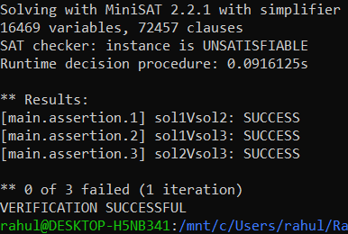

cbmc MagicPairs.c -- unwind 2

* 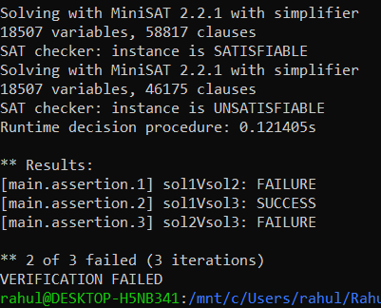

cbmc MagicPairs.c -- unwind 2 -- trace 1

Trace for main.assertion.1:

Violated property:

file MagicPairs.c line 45 function main

sol1Vsol2

return_value_sol1 == return_value_sol2

Trace for main.assertion.3:

Violated property:

file MagicPairs.c line 45 function main

sol1Vsol2

return_value_sol1 == return_value_sol2

Violated property:

file MagicPairs.c line 47 function main

sol2Vsol3

return_value_sol2$0 == return_value_sol3$0

** 2 of 3 failed (3 iterations)

VERIFICATION FAILED

81) **SubtractionGame1.c**

cbmc SubtractionGame1.c -- unwind 1

* 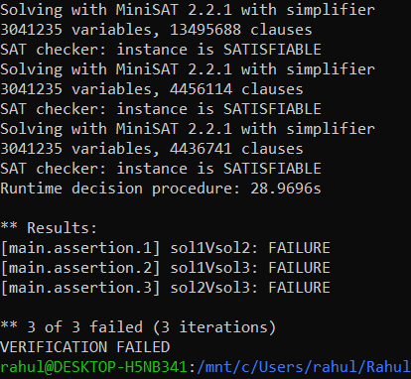

cbmc SubtractionGame1.c -- unwind 1 --trace

Trace for main.assertion.1:

Violated property:

file SubtractionGame1.c line 161 function main

sol1Vsol2

return_value_sol1 == return_value_sol2

Trace for main.assertion.2:

Violated property:

file SubtractionGame1.c line 161 function main

sol1Vsol2

return_value_sol1 == return_value_sol2

Violated property:

file SubtractionGame1.c line 162 function main

sol1Vsol3

return_value_sol1$0 == return_value_sol3

Trace for main.assertion.3:

Violated property:

file SubtractionGame1.c line 161 function main

sol1Vsol2

return_value_sol1 == return_value_sol2

Violated property:

file SubtractionGame1.c line 162 function main

sol1Vsol3

return_value_sol1$0 == return_value_sol3

Violated property:

file SubtractionGame1.c line 163 function main

sol2Vsol3

return_value_sol2$0 == return_value_sol3$0

** 3 of 3 failed (3 iterations)

VERIFICATION FAILED

82) **TheBestBox.c**

cbmc TheBestBox.c -- unwind 1

* 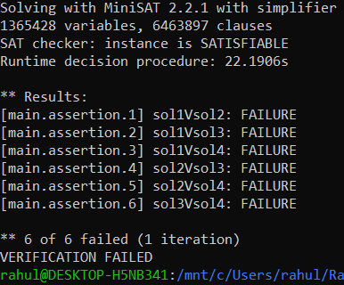

cbmc TheBestBox.c -- unwind 1 --trace

Trace for main.assertion.1:

Violated property:

file TheBestBox.c line 58 function main

sol1Vsol2

IEEE_FLOAT_EQUAL(return_value_sol1, return_value_sol2)

Trace for main.assertion.2:

Violated property:

file TheBestBox.c line 58 function main

sol1Vsol2

IEEE_FLOAT_EQUAL(return_value_sol1, return_value_sol2)

Violated property:

file TheBestBox.c line 59 function main

sol1Vsol3

IEEE_FLOAT_EQUAL(return_value_sol1$0, return_value_sol3)

Trace for main.assertion.3:

Violated property:

file TheBestBox.c line 58 function main

sol1Vsol2

IEEE_FLOAT_EQUAL(return_value_sol1, return_value_sol2)

Violated property:

file TheBestBox.c line 59 function main

sol1Vsol3

IEEE_FLOAT_EQUAL(return_value_sol1$0, return_value_sol3)

Violated property:

file TheBestBox.c line 60 function main

sol1Vsol4

IEEE_FLOAT_EQUAL(return_value_sol1$1, return_value_sol4)

Trace for main.assertion.4:

Violated property:

file TheBestBox.c line 58 function main

sol1Vsol2

IEEE_FLOAT_EQUAL(return_value_sol1, return_value_sol2)

Violated property:

file TheBestBox.c line 59 function main

sol1Vsol3

IEEE_FLOAT_EQUAL(return_value_sol1$0, return_value_sol3)

Violated property:

file TheBestBox.c line 60 function main

sol1Vsol4

IEEE_FLOAT_EQUAL(return_value_sol1$1, return_value_sol4)

Violated property:

file TheBestBox.c line 61 function main

sol2Vsol3

IEEE_FLOAT_EQUAL(return_value_sol2$0, return_value_sol3$0)

Trace for main.assertion.5:

Violated property:

file TheBestBox.c line 58 function main

sol1Vsol2

IEEE_FLOAT_EQUAL(return_value_sol1, return_value_sol2)

Violated property:

file TheBestBox.c line 59 function main

sol1Vsol3

IEEE_FLOAT_EQUAL(return_value_sol1$0, return_value_sol3)

Violated property:

file TheBestBox.c line 60 function main

sol1Vsol4

IEEE_FLOAT_EQUAL(return_value_sol1$1, return_value_sol4)

Violated property:

file TheBestBox.c line 61 function main

sol2Vsol3

IEEE_FLOAT_EQUAL(return_value_sol2$0, return_value_sol3$0)

Violated property:

file TheBestBox.c line 62 function main

sol2Vsol4

IEEE_FLOAT_EQUAL(return_value_sol2$1, return_value_sol4$0)

Trace for main.assertion.6:

Violated property:

file TheBestBox.c line 59 function main

sol1Vsol3

IEEE_FLOAT_EQUAL(return_value_sol1$0, return_value_sol3)

Violated property:

file TheBestBox.c line 60 function main

sol1Vsol4

IEEE_FLOAT_EQUAL(return_value_sol1$1, return_value_sol4)

Violated property:

file TheBestBox.c line 61 function main

sol2Vsol3

IEEE_FLOAT_EQUAL(return_value_sol2$0, return_value_sol3$0)

Violated property:

file TheBestBox.c line 62 function main

sol2Vsol4

IEEE_FLOAT_EQUAL(return_value_sol2$1, return_value_sol4$0)

Violated property:

file TheBestBox.c line 63 function main

sol3Vsol4

IEEE_FLOAT_EQUAL(return_value_sol3$1, return_value_sol4$1)

** 6 of 6 failed (1 iteration)

VERIFICATION FAILED

83) **YourNameIsMyName.c**

cbmc YourNameIsMyName.c -- unwind 1

* 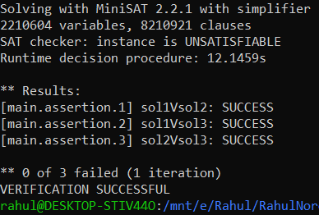

cbmc YourNameIsMyName.c -- unwind 2

* 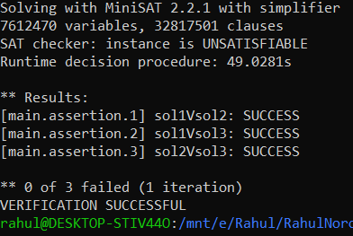

cbmc YourNameIsMyName.c -- unwind 3

* 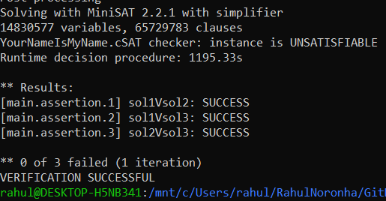

cbmc YourNameIsMyName.c -- unwind 4

* Time exceeded, assume it is unsatisfiable.

1. AppyAndContest.c

cbmc AppyAndContest.c --unwind 1

* 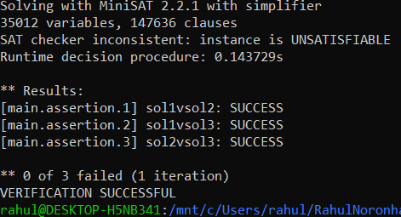

cbmc AppyAndContest.c --unwind 2

* 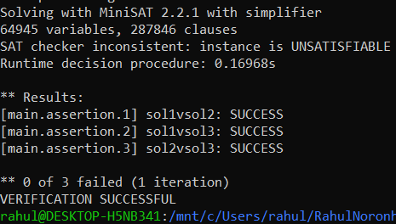

cbmc AppyAndContest.c --unwind 3

* 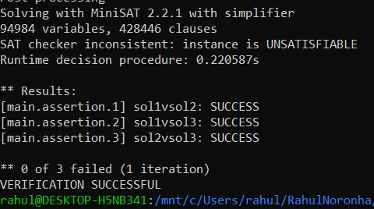

cbmc AppyAndContest.c --unwind 4

* 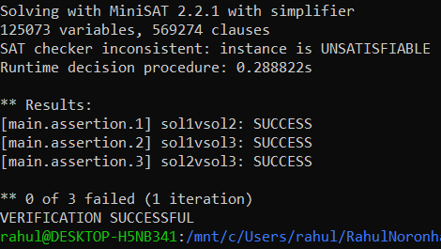

cbmc AppyAndContest.c --unwind 5

* 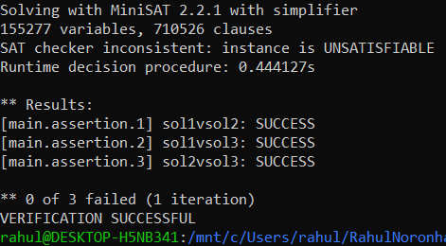

cbmc AppyAndContest.c --unwind 10

* 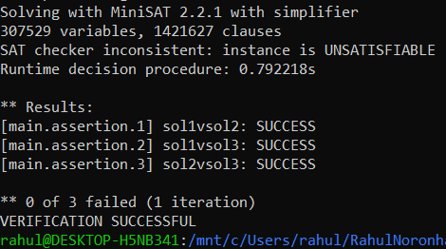

1. AproblemOnSticks.c

cbmc AProblemOnSticks.c --unwind 1

* 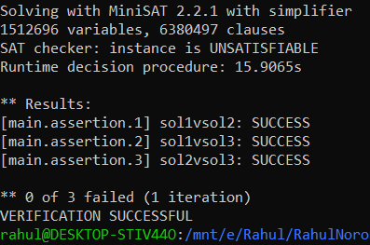

cbmc AProblemOnSticks.c --unwind 2

* Unsatisfiable by time exceeded.

1. **Bread.c**

cbmc Bread.c --unwind 1

* 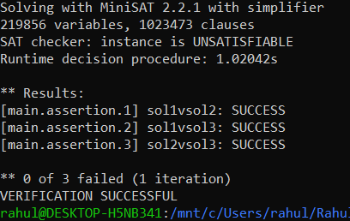

cbmc Bread.c --unwind 2

* 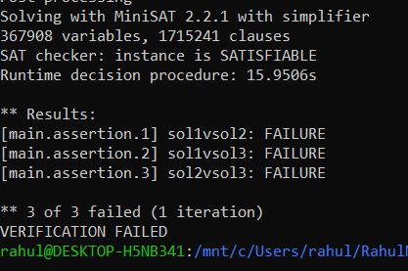

cbmc Bread.c --unwind 2 --trace

Trace for main.assertion.1:

Violated property:

file Bread.c line 130 function main

sol1vsol2

return_value_sol1 == return_value_sol2

Trace for main.assertion.2:

Violated property:

file Bread.c line 130 function main

sol1vsol2

return_value_sol1 == return_value_sol2

Violated property:

file Bread.c line 131 function main

sol1vsol3

return_value_sol1$0 == return_value_sol3

Trace for main.assertion.3:

Violated property:

file Bread.c line 130 function main

sol1vsol2

return_value_sol1 == return_value_sol2

Violated property:

file Bread.c line 131 function main

sol1vsol3

return_value_sol1$0 == return_value_sol3Violated property:

file Bread.c line 132 function main

sol2vsol3

return_value_sol2$0 == return_value_sol3$0

** 3 of 3 failed (1 iteration)

VERIFICATION FAILED

1. **PlayingWithGrids.c**

cbmc PlayingWithGrids.c -- unwind 1

* 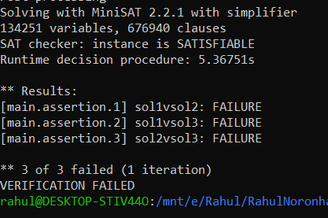

cbmc PlayingWithGrids.c -- unwind 1 --trace

Trace for main.assertion.1:

Violated property:

file PlayingWithGrids.c line 49 function main

sol1vsol2

(signed long int)return_value_sol1 == return_value_sol2

Trace for main.assertion.2:

Violated property:

file PlayingWithGrids.c line 49 function main

sol1vsol2

(signed long int)return_value_sol1 == return_value_sol2

Violated property:

file PlayingWithGrids.c line 50 function main

sol1vsol3

(signed long int)return_value_sol1$0 == return_value_sol3

Trace for main.assertion.3:

Violated property:

file PlayingWithGrids.c line 49 function main

sol1vsol2

(signed long int)return_value_sol1 == return_value_sol2

Violated property:

file PlayingWithGrids.c line 50 function main

sol1vsol3

(signed long int)return_value_sol1$0 == return_value_sol3

Violated property:

file PlayingWithGrids.c line 51 function main

sol2vsol3

return_value_sol2$0 == return_value_sol3$0

** 3 of 3 failed (1 iteration)

VERIFICATION FAILED

1. **DeleteAndFindSum.c**

cbmc DeleteAndFindSum.c -- unwind 1

* 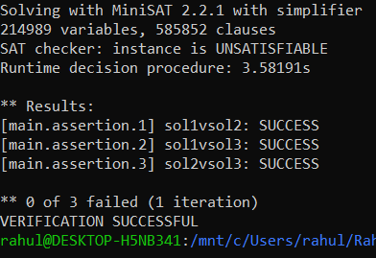

cbmc DeleteAndFindSum.c -- unwind 2

* 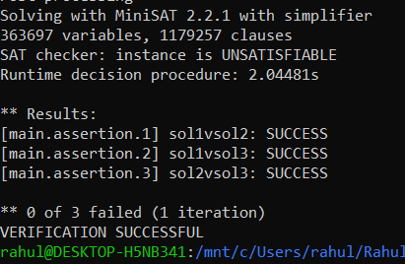

cbmc DeleteAndFindSum.c -- unwind 3

* 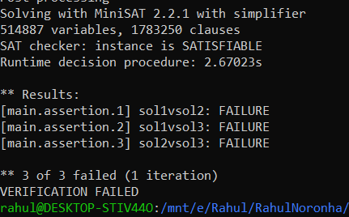

cbmc DeleteAndFindSum.c -- unwind 3 -- trace

Trace for main.assertion.1:

Violated property:

file DeleteAndFindSum.c line 99 function main

sol1vsol2

return_value_sol1 == return_value_sol2

Trace for main.assertion.2:

Violated property:

file DeleteAndFindSum.c line 99 function main

sol1vsol2

return_value_sol1 == return_value_sol2

Violated property:

file DeleteAndFindSum.c line 100 function main

sol1vsol3

return_value_sol1$0 == return_value_sol3

Trace for main.assertion.3:

Violated property:

file DeleteAndFindSum.c line 99 function main

sol1vsol2

return_value_sol1 == return_value_sol2

Violated property:

file DeleteAndFindSum.c line 100 function main

sol1vsol3

return_value_sol1$0 == return_value_sol3

Violated property:

file DeleteAndFindSum.c line 101 function main

sol2vsol3

return_value_sol2$0 == return_value_sol3$0

** 3 of 3 failed (1 iteration)

VERIFICATION FAILED

1. **MultipleOfThree.c**

cbmc MultipleOfThree.c -- unwind 1

* 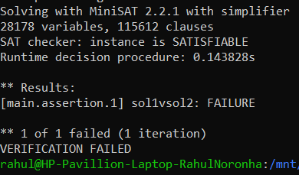

cbmc MultipleOfThree.c -- unwind 1 -- trace

Trace for main.assertion.1:

Violated property:

file MultipleOfThree.c line 73 function main

sol1vsol2

return_value_sol1 == return_value_sol2

** 1 of 1 failed (1 iteration)

VERIFICATION FAILED

1. **GoodMedian.c**

cbmc GoodMedian.c --unwind 1

* 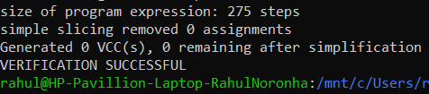

cbmc GoodMedian.c --unwind 2

* 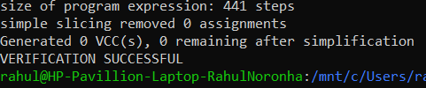

cbmc GoodMedian.c --unwind 3

* 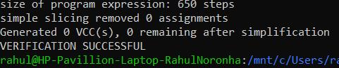

cbmc GoodMedian.c --unwind 4

* 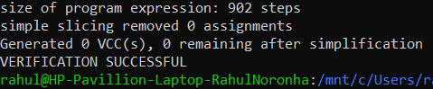

cbmc GoodMedian.c --unwind 5

* 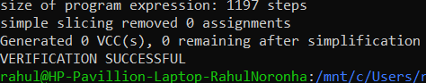

cbmc GoodMedian.c --unwind 10

* Time limit exceeded. So, assume unsatisfiability.

1. **PleaseLikeMe.c**

cbmc PleaseLikeMe.c --unwind 1 --trace

* 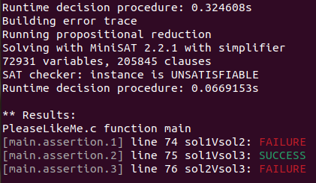

Trace for main.assertion.1:

Violated property:

file PleaseLikeMe.c function main line 74 thread 0

sol1Vsol2

return_value_sol1 == return_value_sol2

Trace for main.assertion.3:

Violated property:

file PleaseLikeMe.c function main line 74 thread 0

sol1Vsol2

return_value_sol1 == return_value_sol2

Violated property:

file PleaseLikeMe.c function main line 76 thread 0

sol2Vsol3

return_value_sol2$0 == return_value_sol3$0

** 2 of 3 failed (2 iterations)

VERIFICATION FAILED

1. **SurajGoesShopping.c**

cbmc SurajGoesShopping.c --unwind 1

* 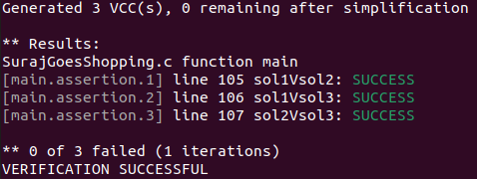

cbmc SurajGoesShopping.c --unwind 2 --trace

* 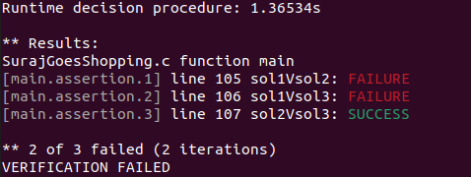

Trace for main.assertion.1:

Violated property:

file SurajGoesShopping.c function main line 105 thread 0

sol1Vsol2

return_value_sol1 == return_value_sol2

Trace for main.assertion.2:

Violated property:

file SurajGoesShopping.c function main line 105 thread 0

sol1Vsol2

return_value_sol1 == return_value_sol2

Violated property:

file SurajGoesShopping.c function main line 106 thread 0

sol1Vsol3

return_value_sol1$0 == return_value_sol3

** 2 of 3 failed (2 iterations)

VERIFICATION FAILED

1. **OddDivisiors.c**

cbmc OddDivisors.c -- unwind 1

* 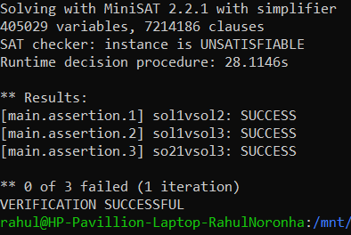

cbmc OddDivisors.c -- unwind 2

* 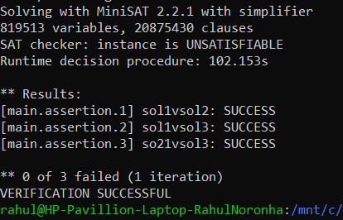

cbmc OddDivisors.c -- unwind 3

* 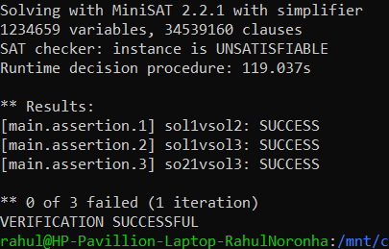

cbmc OddDivisors.c -- unwind 4

* 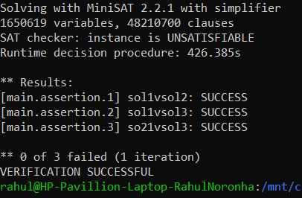

cbmc OddDivisors.c -- unwind 5

* 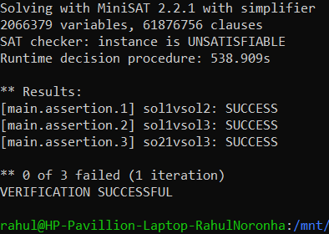

cbmc OddDivisors.c -- unwind 10

* Time exceeded, assume unsatisfiability.

1. **ChefAndStones.c**

cbmc ChefAndStones.c --unwind 1

* 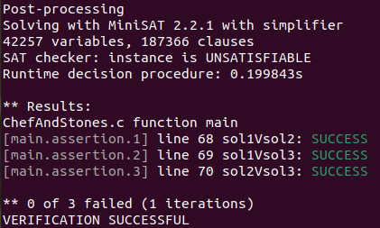

cbmc ChefAndStones.c --unwind 2 --trace

* 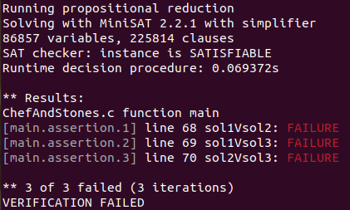

Trace for main.assertion.1:

Violated property:

file ChefAndStones.c function main line 68 thread 0

sol1Vsol2

return_value_sol1 == return_value_sol2

Trace for main.assertion.2:

Violated property:

file ChefAndStones.c function main line 68 thread 0

sol1Vsol2

return_value_sol1 == return_value_sol2

Violated property:

file ChefAndStones.c function main line 69 thread 0

sol1Vsol3

return_value_sol1$0 == return_value_sol3

Trace for main.assertion.3:

Violated property:

file ChefAndStones.c function main line 68 thread 0

sol1Vsol2

return_value_sol1 == return_value_sol2

Violated property:

file ChefAndStones.c function main line 70 thread 0

sol2Vsol3

return_value_sol2$0 == return_value_sol3$0

** 3 of 3 failed (3 iterations)

VERIFICATION FAILED

1. **WorldRecord.c**

cbmc WorldRecord.c -- unwind

* 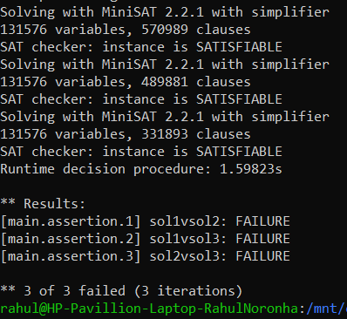

cbmc WorldRecord.c --unwind --trace

Trace for main.assertion.1:

Violated property:

file WorldRecord.c line 57 function main

sol1vsol2

return_value_sol1 == return_value_sol2

Trace for main.assertion.2:

Violated property:

file WorldRecord.c line 58 function main

sol1vsol3

return_value_sol1$0 == return_value_sol3

Trace for main.assertion.3:

Violated property:

file WorldRecord.c line 58 function main

sol1vsol3

return_value_sol1$0 == return_value_sol3

Violated property:

file WorldRecord.c line 59 function main

sol2vsol3

return_value_sol2$0 == return_value_sol3$0

** 3 of 3 failed (3 iterations)

VERIFICATION FAILED

96) **SplitSums.c**

cbmc SplitSums.c --unwind 1

* 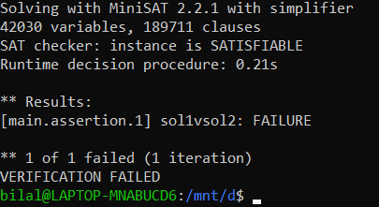

cbmc SplitSums.c --unwind 1 --trace

Trace for main.assertion.1:

Violated property:

file SplitSums.c line 71 function main

sol1vsol2

(unsigned long int)return_value_sol1$1 == return_value_sol2$2

** 1 of 1 failed (1 iteration)

VERIFICATION FAILED

1. **CollegeLife4.c**

cbmc CollegeLife4.c --unwind 1

* 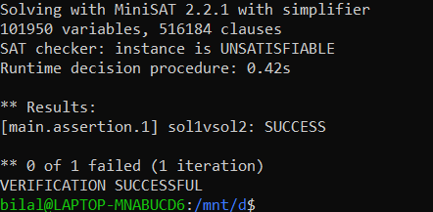

cbmc CollegeLife4.c -- unwind 2

* Time exceeded, assume unsatisfiability.

1. **GuessItRight.c**

cbmc GuessItRight.c --unwind 1 –trace

* 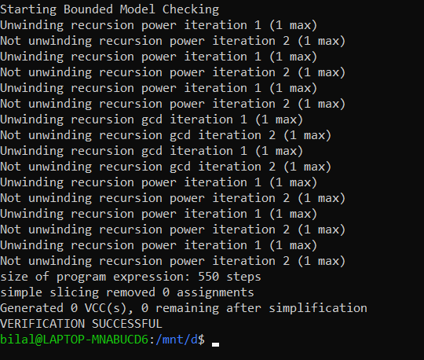

cbmc GuessItRight.c --unwind 10 –trace

* 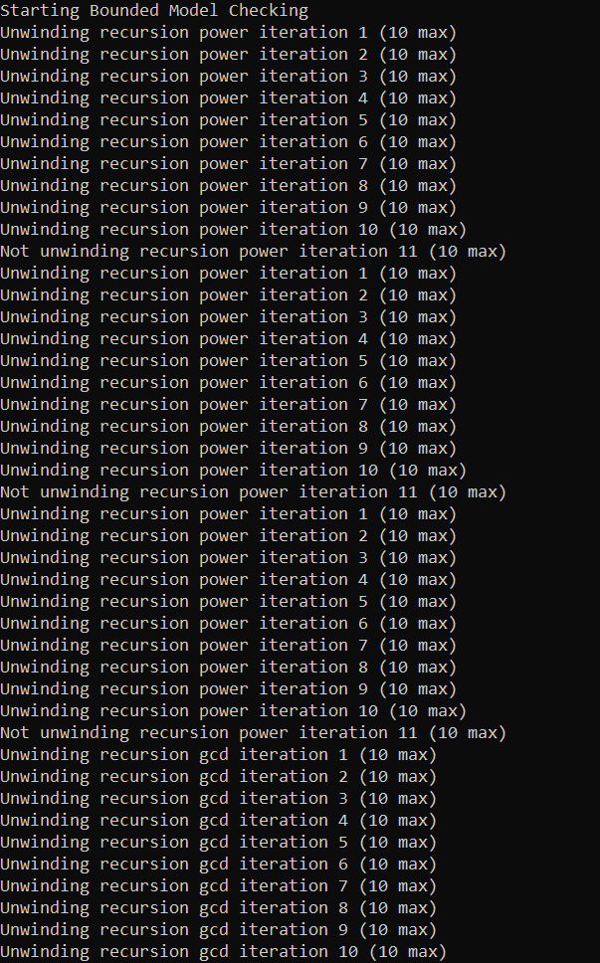
* 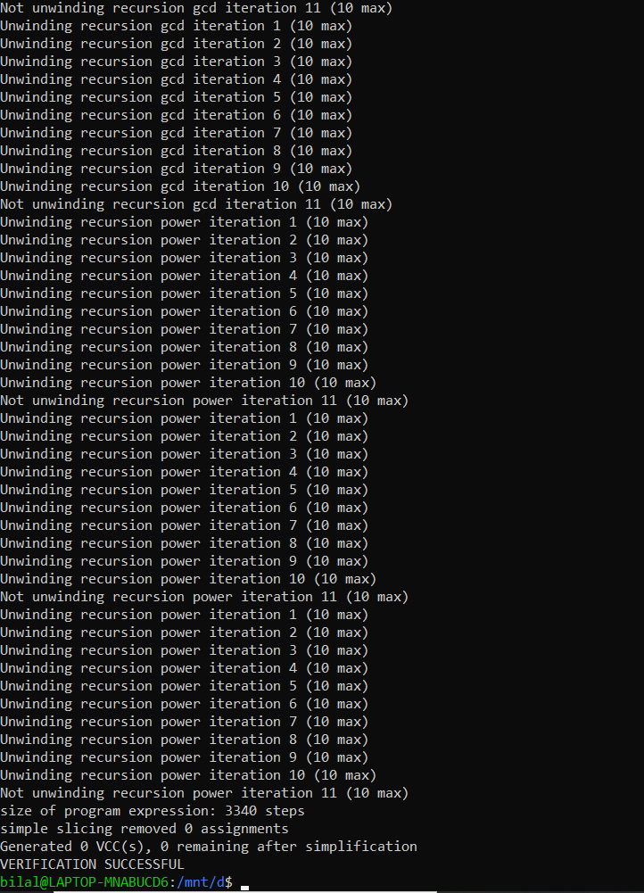

1. **ChefAndHisFriends.c**

cbmc ChefAndHisFriend.c --unwind 1

* 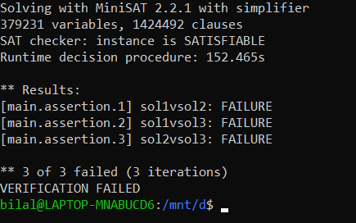

cbmc ChefAndHisFriend.c --unwind 1 --trace

Trace for main.assertion.1:

Violated property:

file ChefAndHisFriend.c line 119 function main

sol1vsol2

return_value_sol1 == return_value_sol2

Trace for main.assertion.2:

Violated property:

file ChefAndHisFriend.c line 119 function main

sol1vsol2

return_value_sol1 == return_value_sol2

Violated property:

file ChefAndHisFriend.c line 120 function main

sol1vsol3

return_value_sol1$0 == return_value_sol3

Trace for main.assertion.3:

Violated property:

file ChefAndHisFriend.c line 121 function main

sol2vsol3

return_value_sol2$0 == return_value_sol3$0

** 3 of 3 failed (2 iterations)

VERIFICATION FAILED

1. ChefJumping.c

cbmc ChefJumping.c -- unwind 1

* 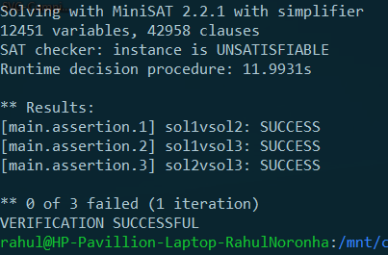

cbmc ChefJumping.c -- unwind 2

* 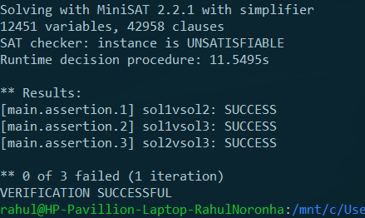

cbmc ChefJumping.c -- unwind 3

* 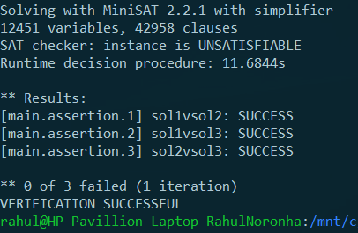

cbmc ChefJumping.c -- unwind 4

* 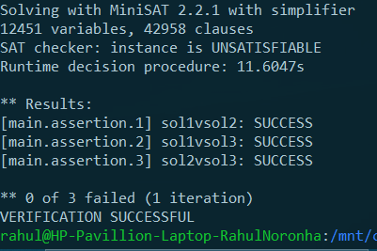

cbmc ChefJumping.c -- unwind 5

* 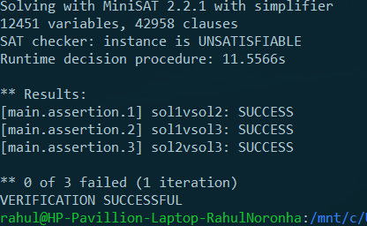

cbmc ChefJumping.c -- unwind 10

* 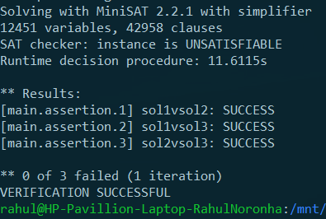

1. PalindromicSubstrings.c

cbmc PalindromicSubstrings.c -- unwind 1

* 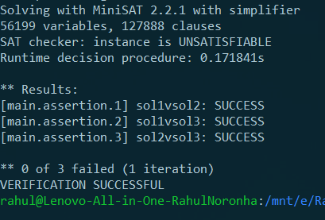

cbmc PalindromicSubstrings.c -- unwind 2

* 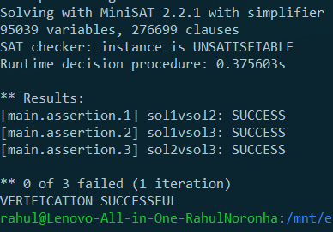

cbmc PalindromicSubstrings.c -- unwind 3

* 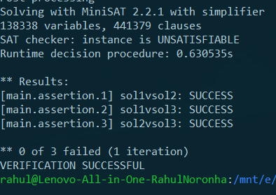

cbmc PalindromicSubstrings.c -- unwind 4

* 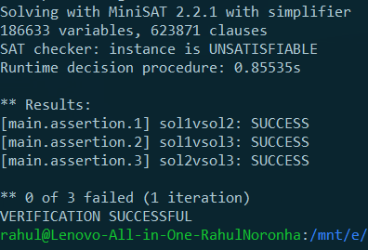

cbmc PalindromicSubstrings.c -- unwind 5

* 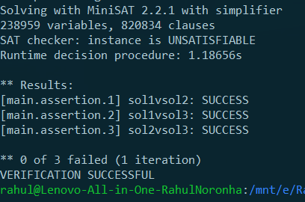

cbmc PalindromicSubstrings.c -- unwind 10

* 